IWM20241205P240000
Logic: MA(1) > MA(2) is buy signal
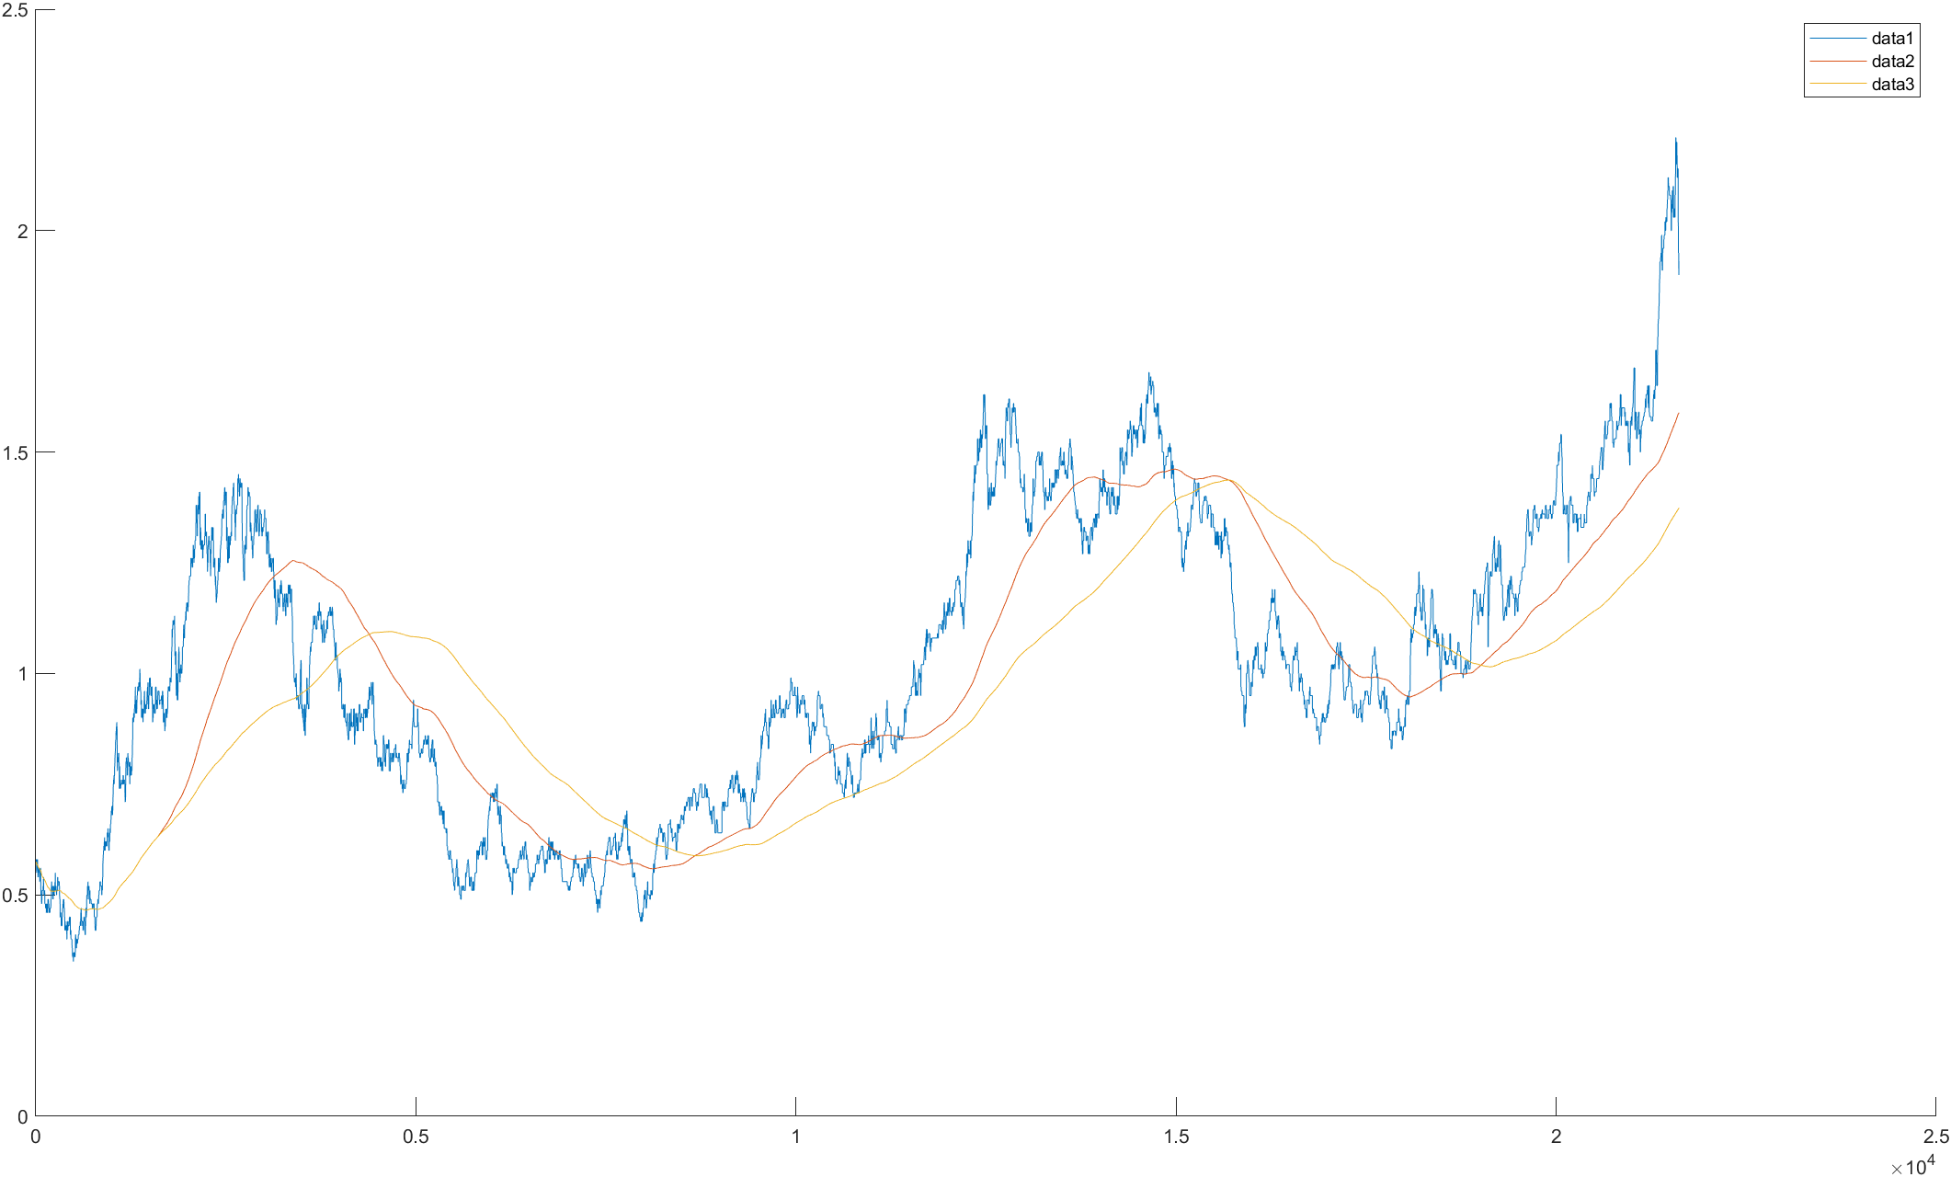
Earning ratio based on SMA vs SMA 100-5000
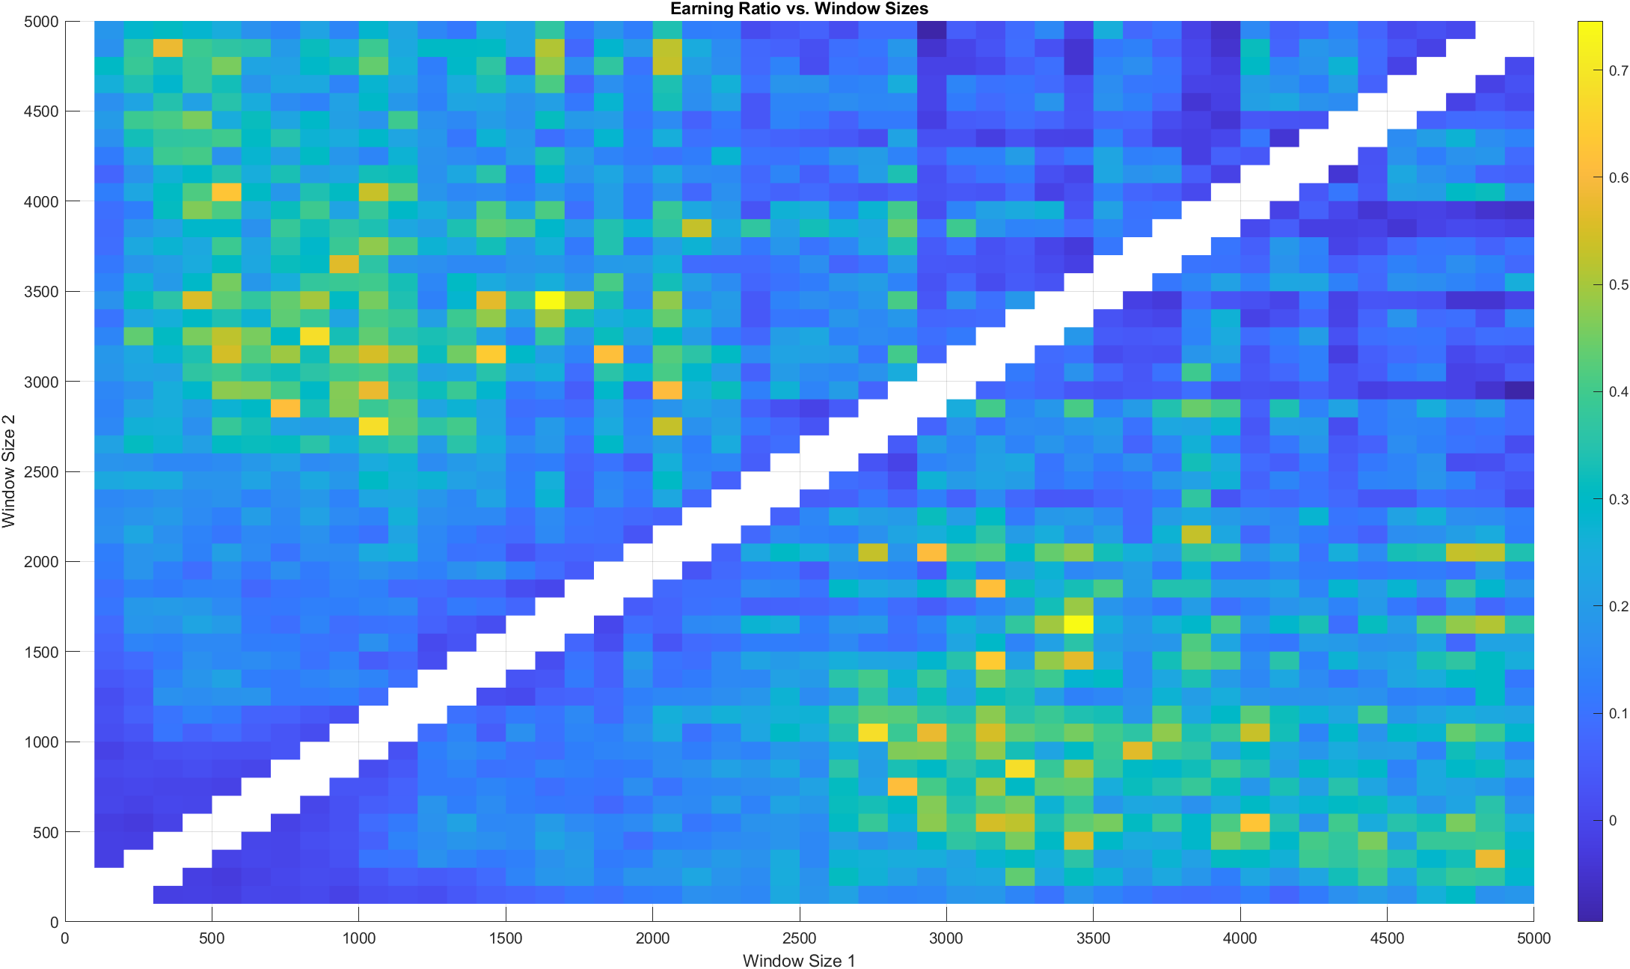
Concentrated at 500-100 vs 2500-3500

Earning ratio based on linear MA vs linear MA 100-5000
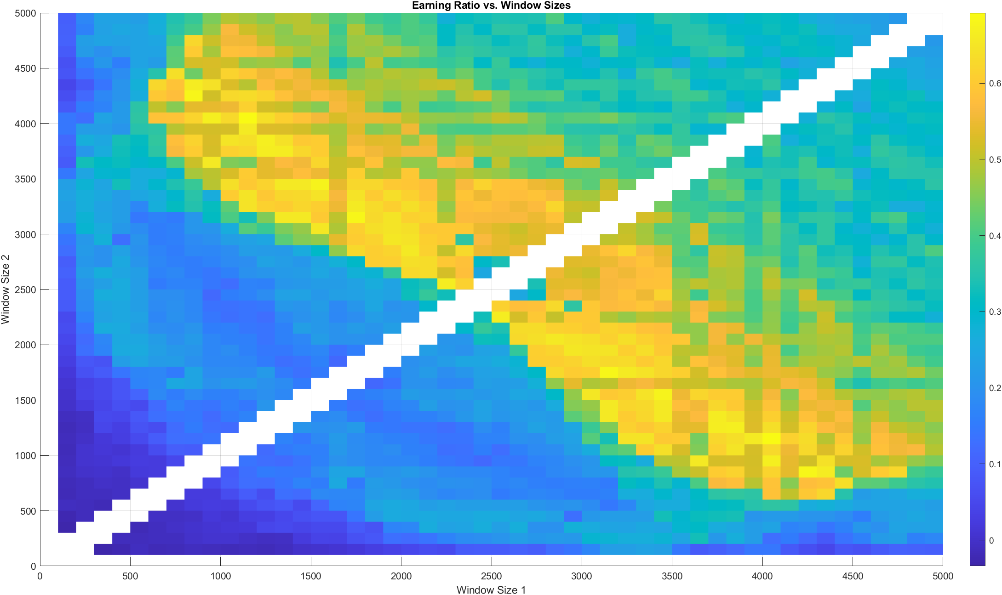
Much larger area of high earning ratio, Concentrated at 700-2500 vs 3000-4000
Earning ratio based on square MA vs square MA 100-5000
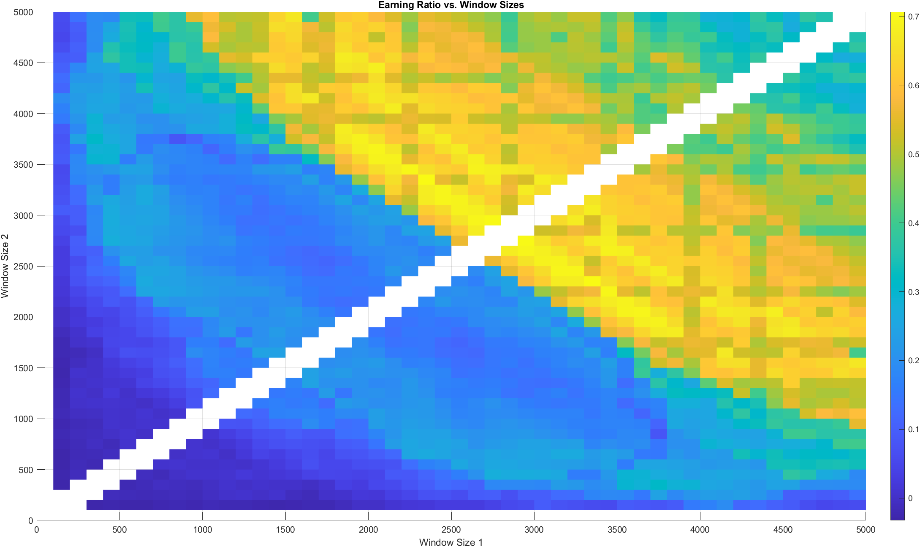
A little smaller high-earning area than linear

Earning ratio based on EMA vs EMA 100-5000
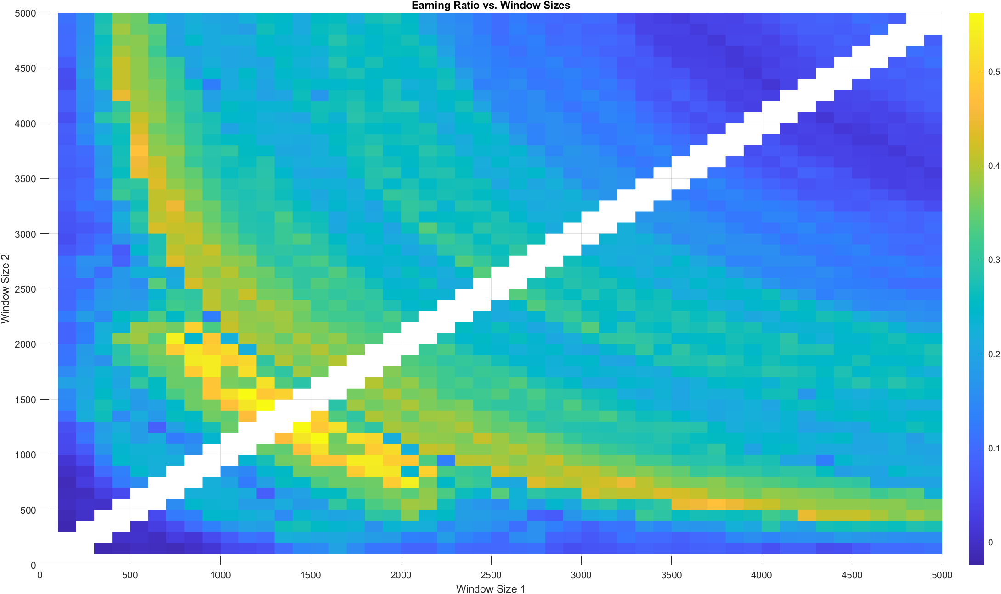
Pretty bad
Earning ratio based on SMMA vs SMMA 100-5000
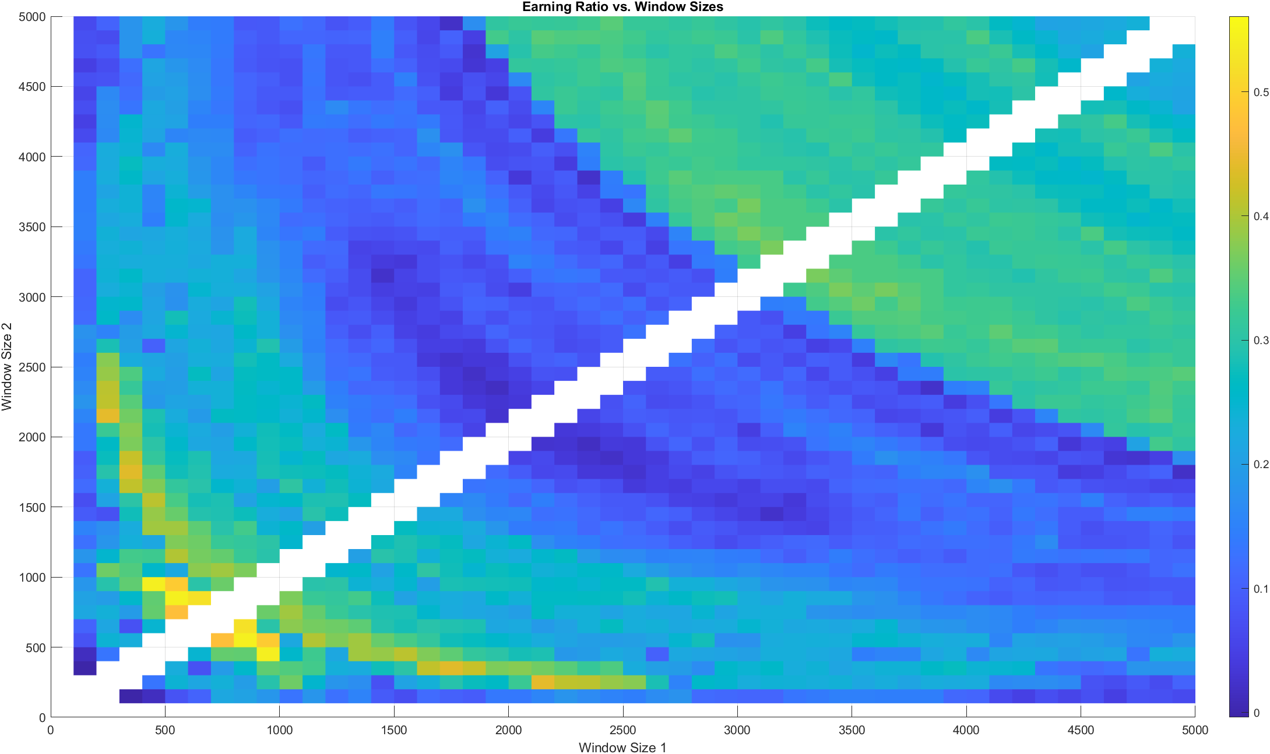
Even worse, but the MMA itself is interesting

Data 2 SMMA data 3 SMA
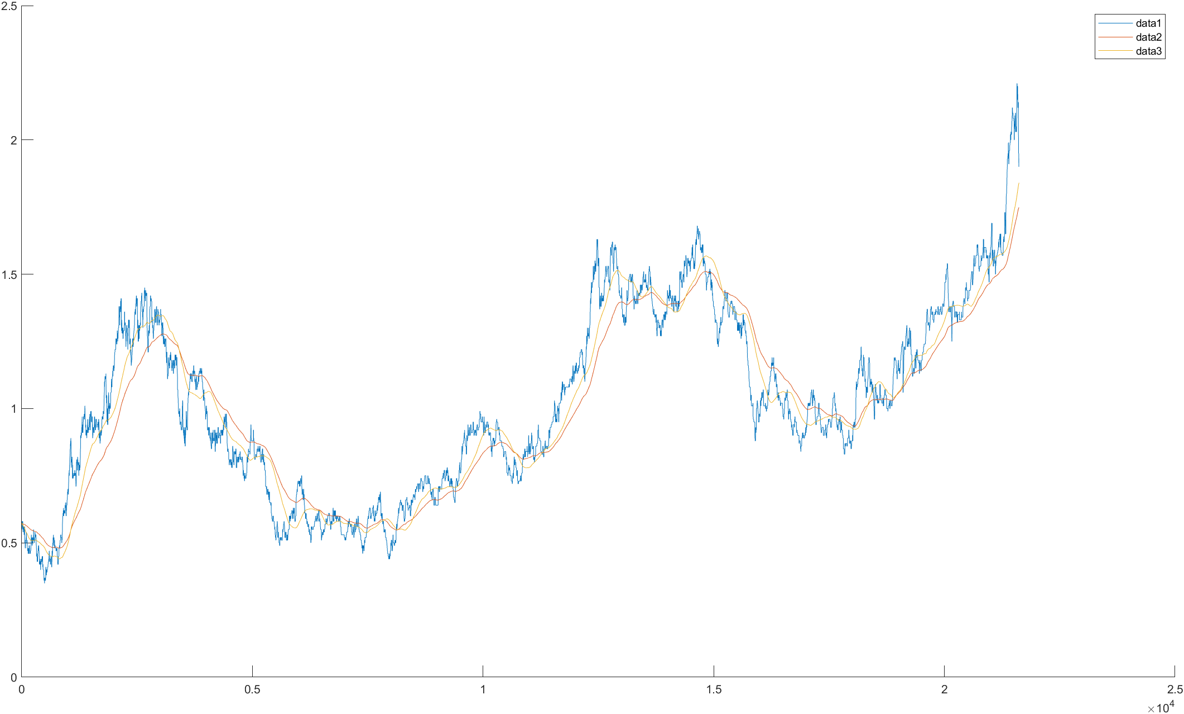
ER based on SMMA (1) vs SMA (2) 100-5000
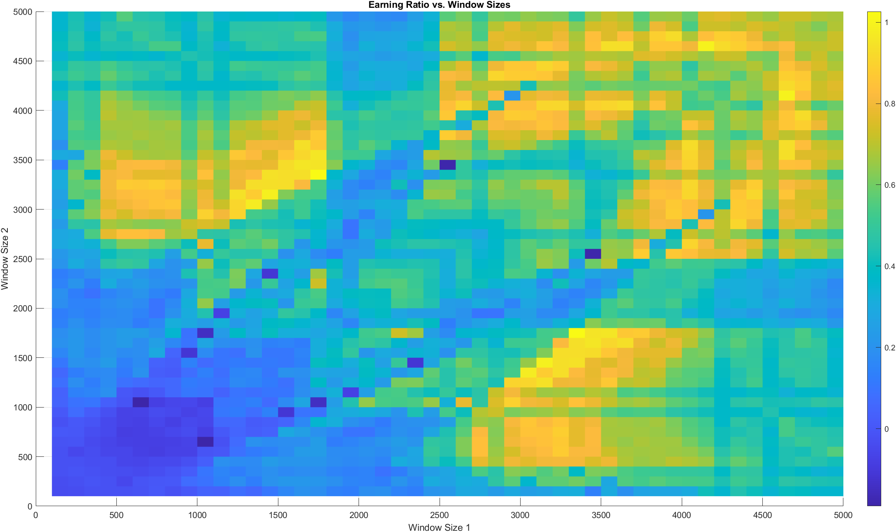
Surprisingly good!

ER SMA(1) vs linear MA(2)
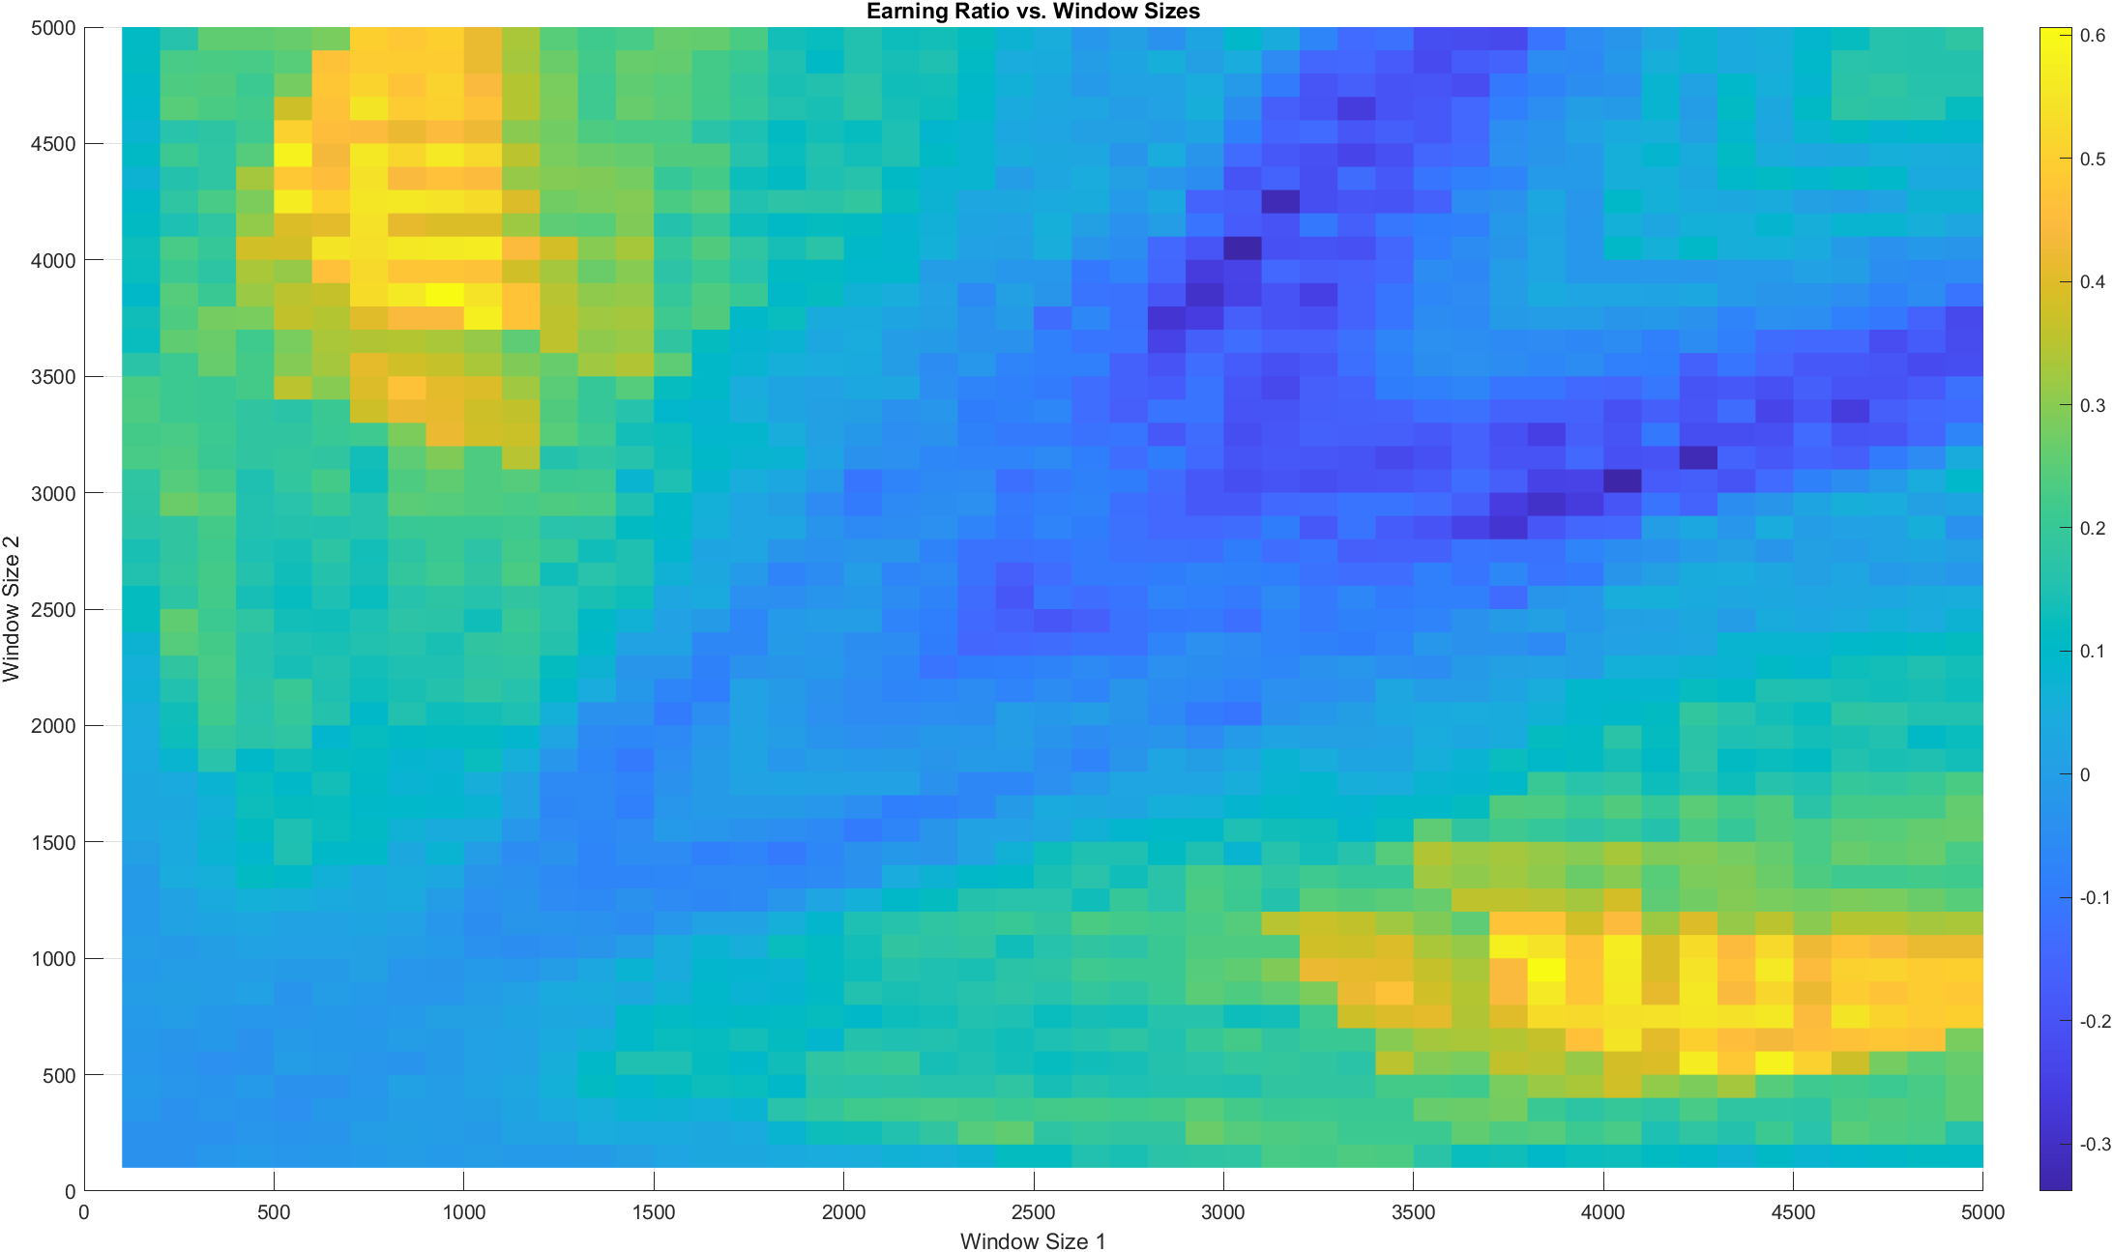
Classic concentration area SMA 4000-5000 linear MA 500-1000
ER SMA vs Square MA is similar but worse

IWM241206C240000
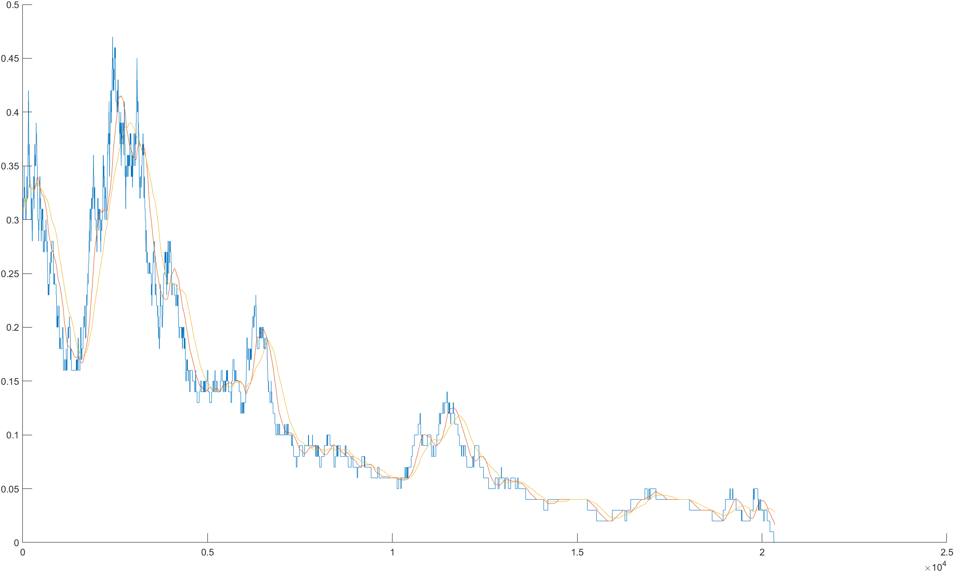
ER SMA vs SMA
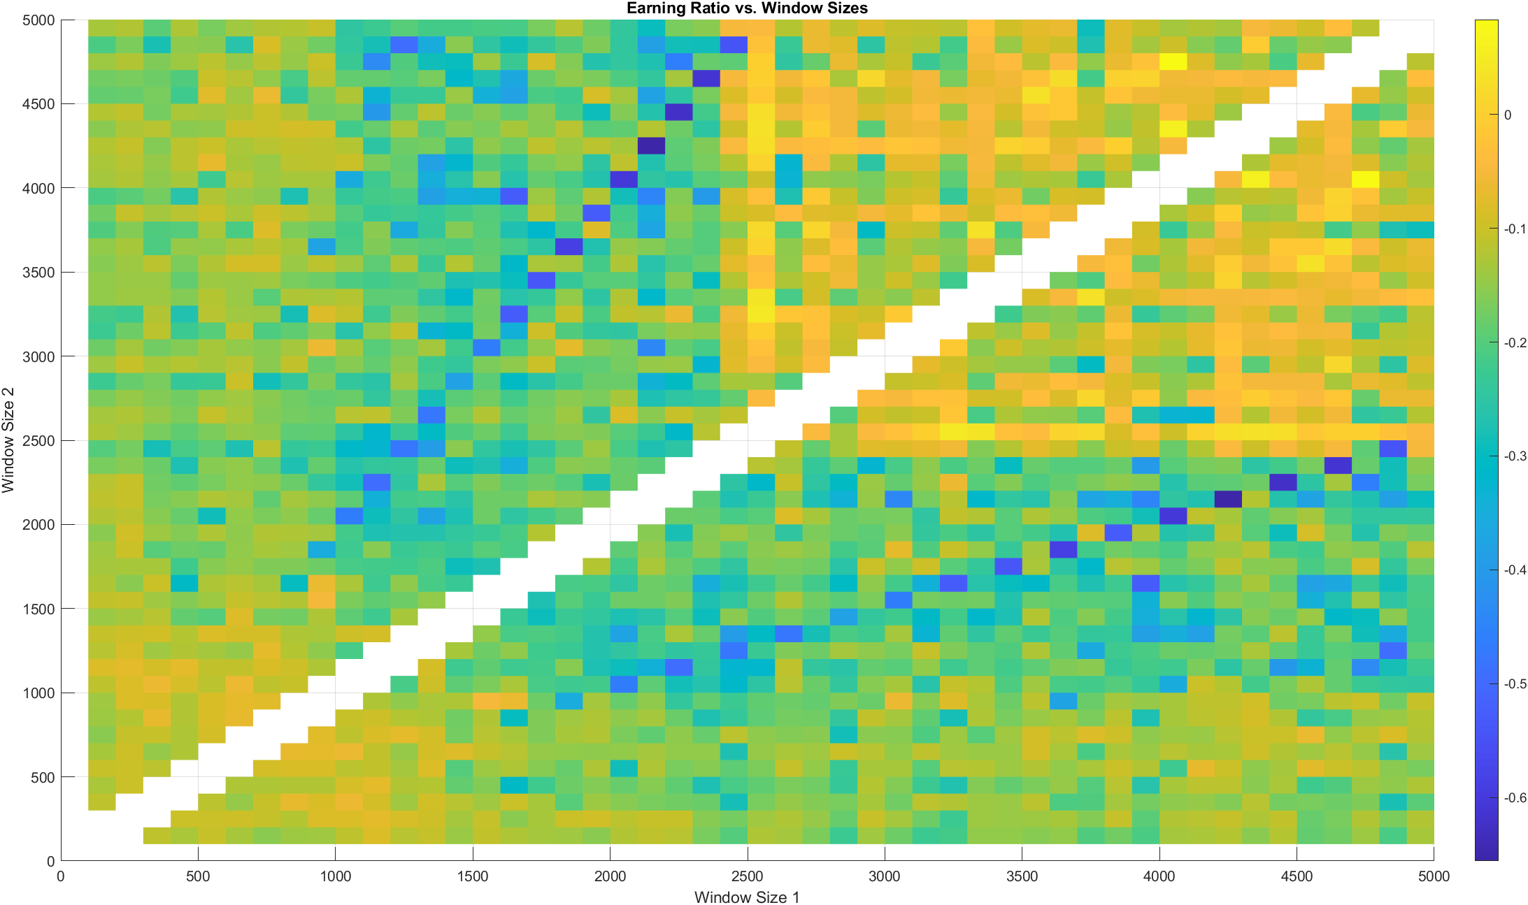

ER linear MA vs linear MA
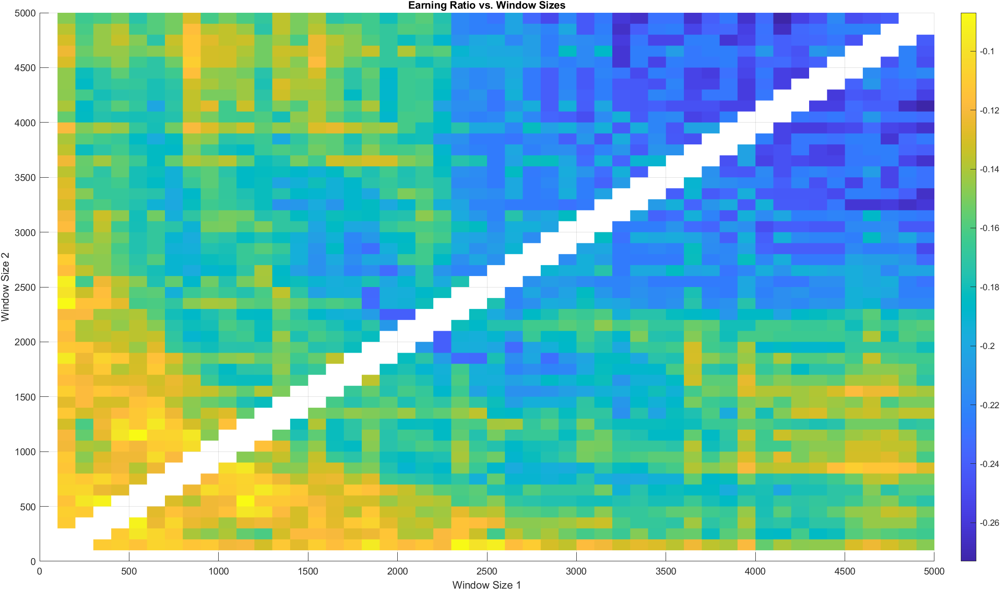
ER suqare MA vs square MA
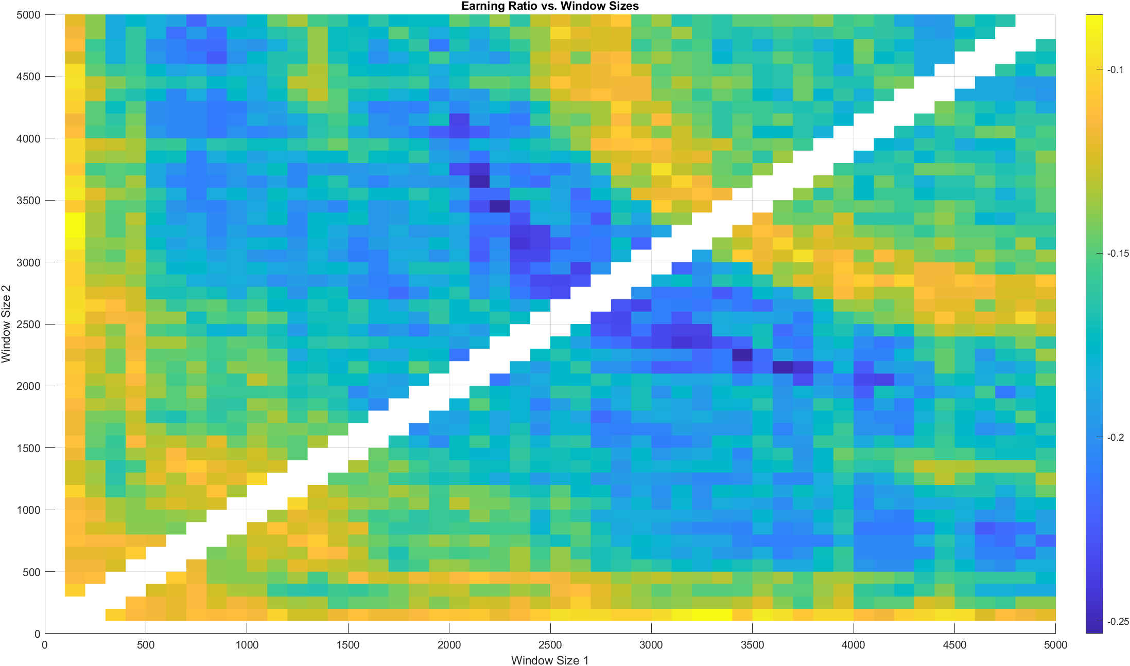

ER EMA vs EMA (is shit without doubt)
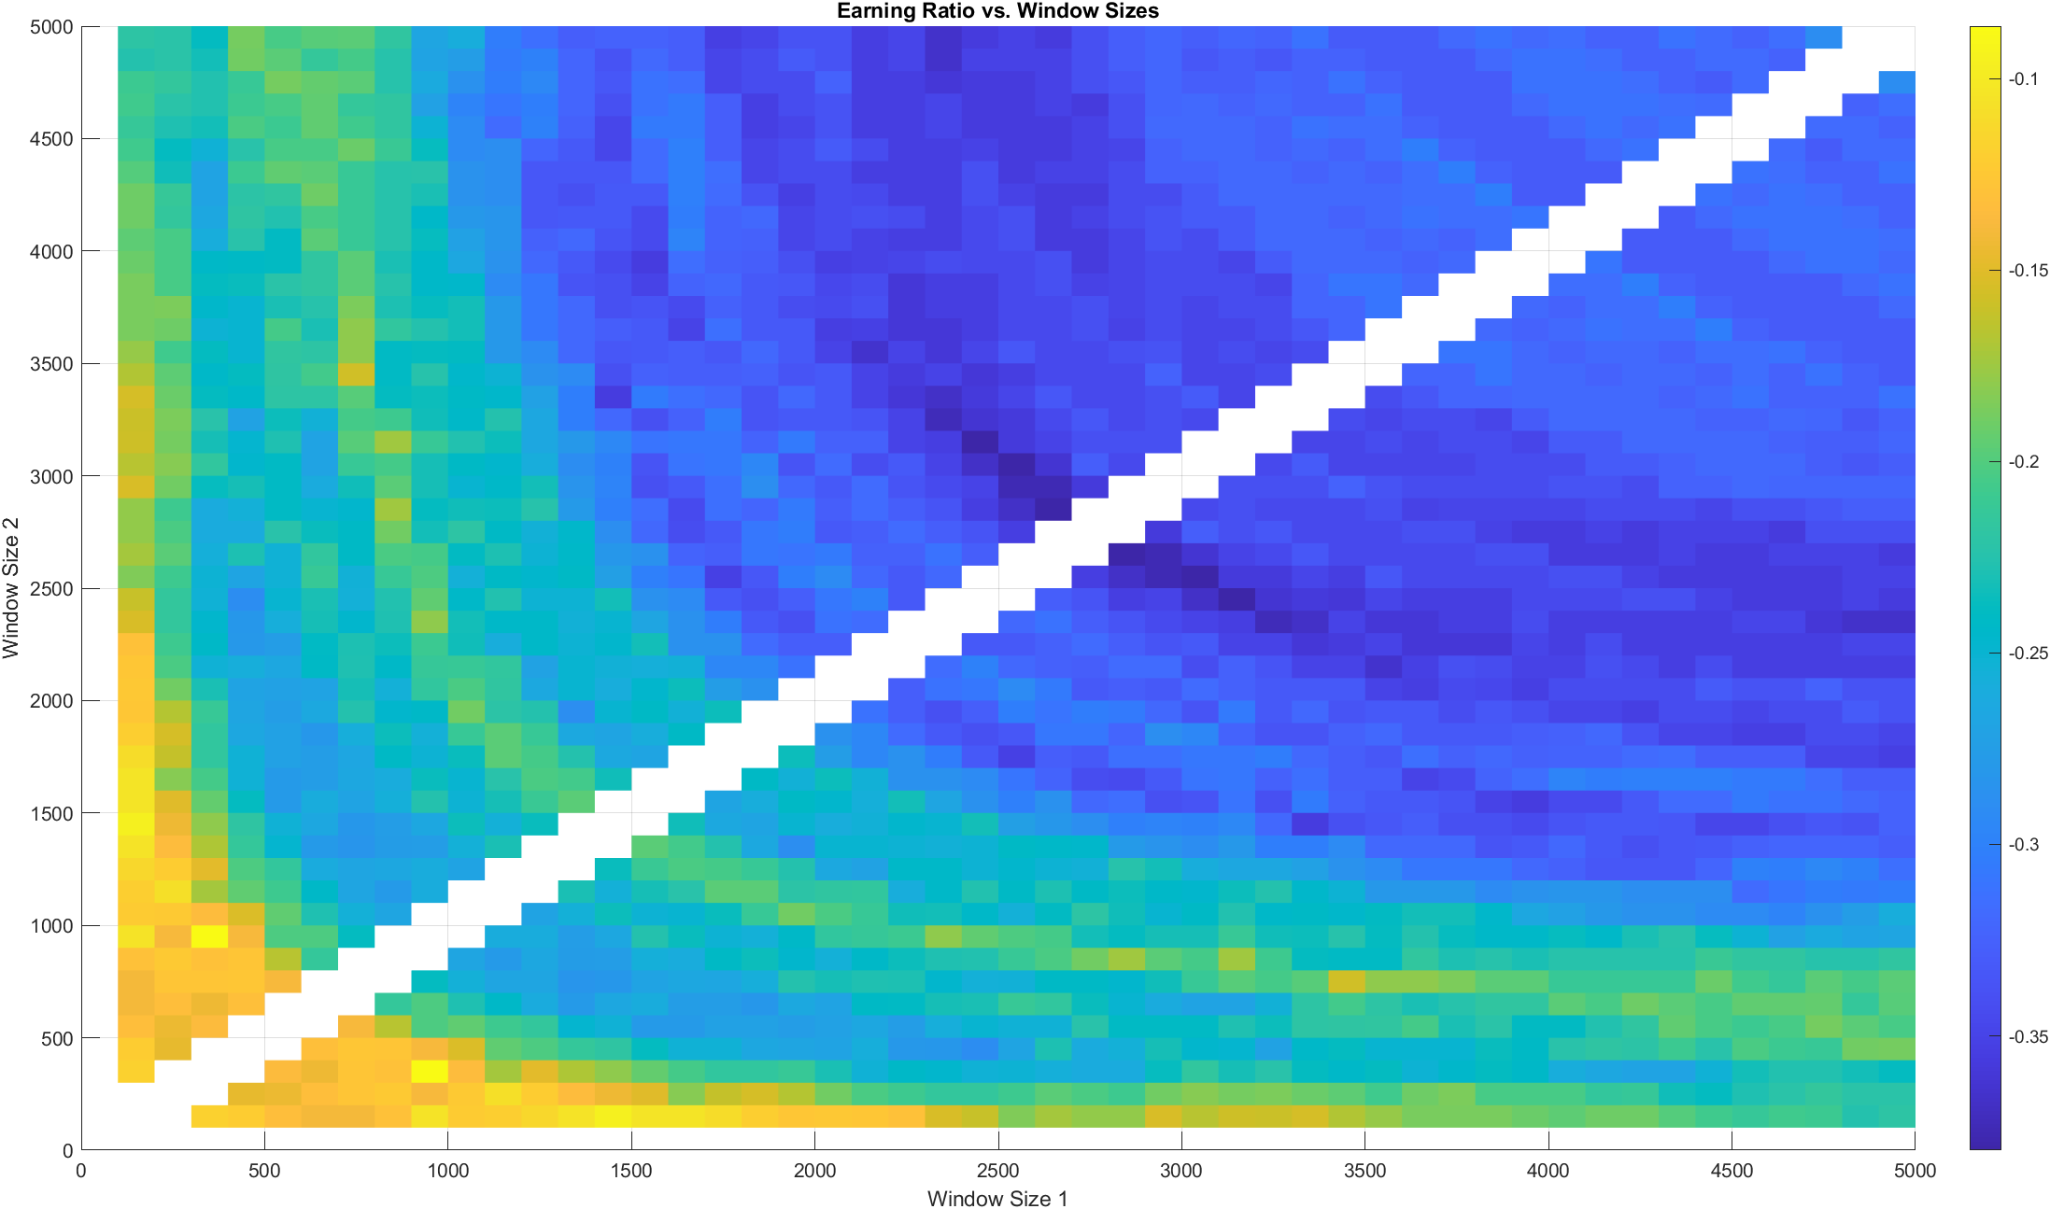
ER SMMA vs SMA (only positive ER so far)
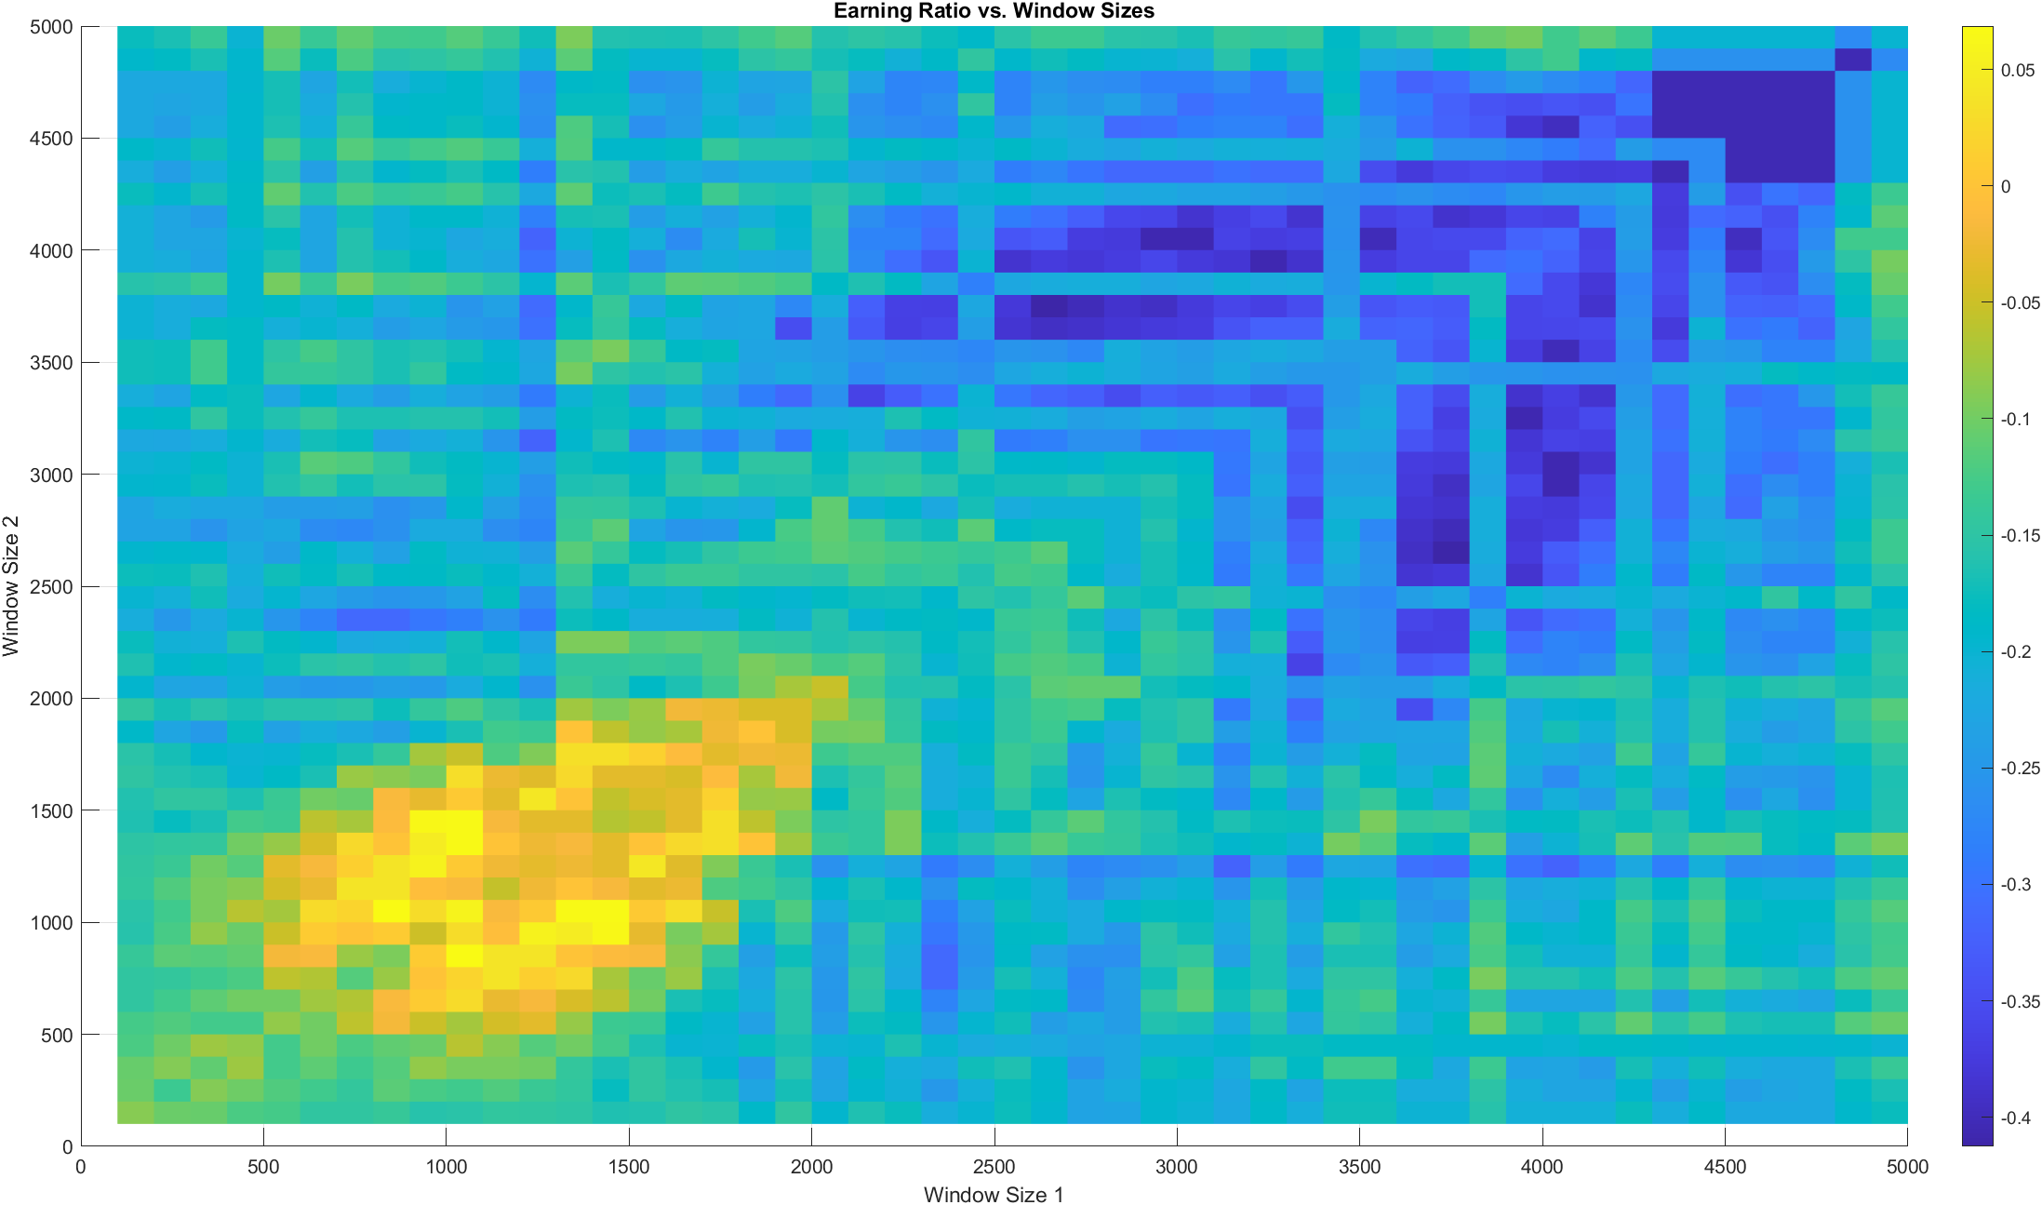

IWM241206P240000
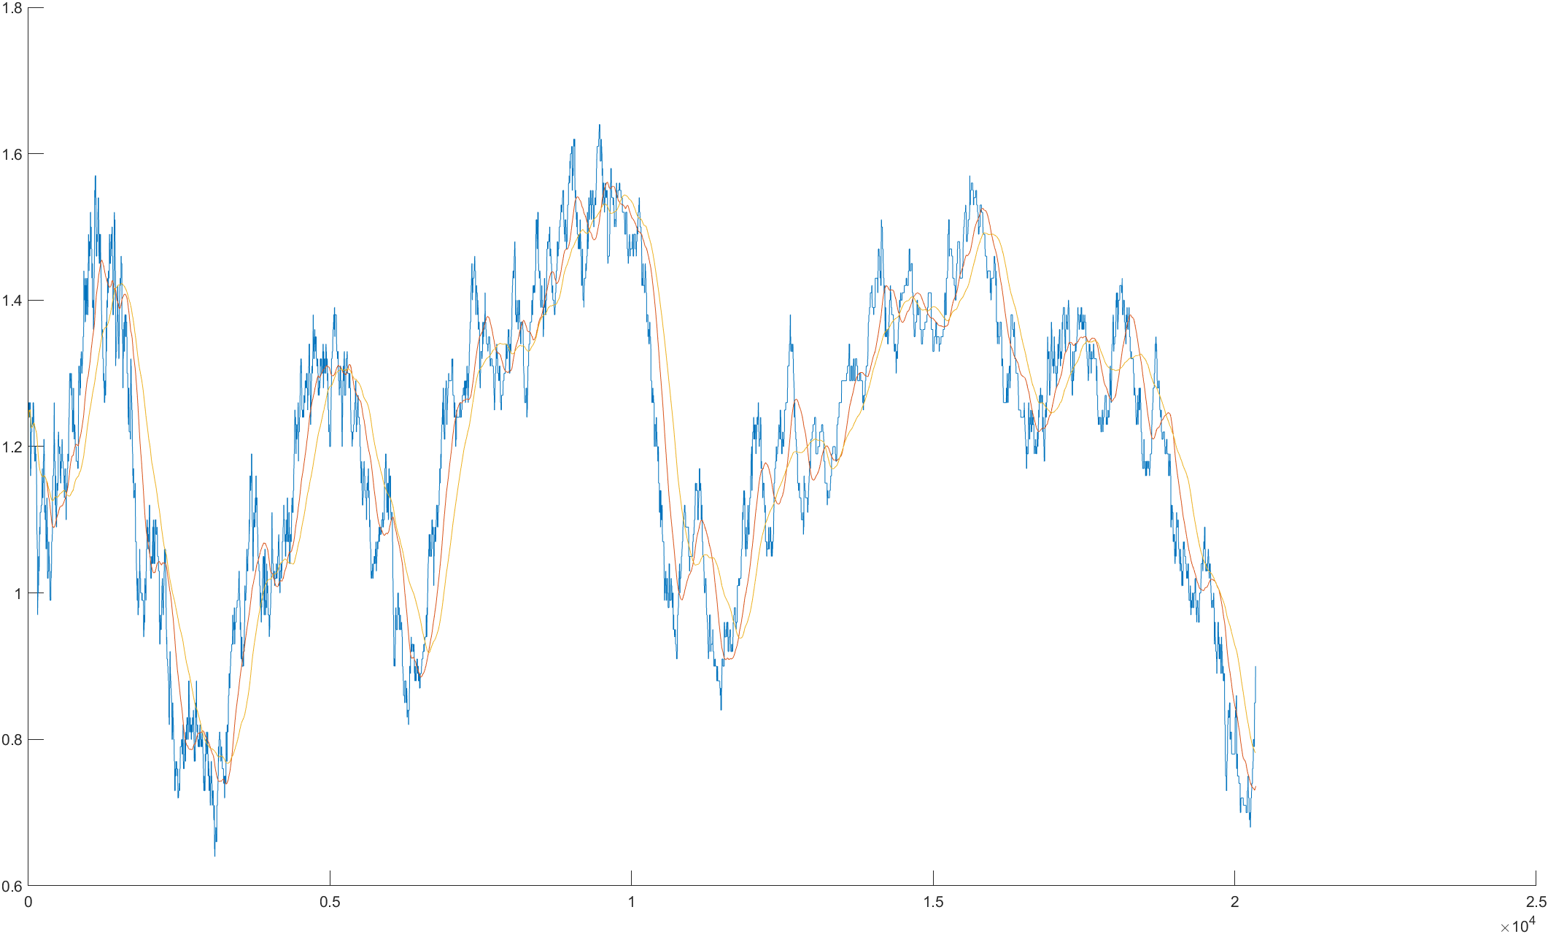
ER SMA vs SMA
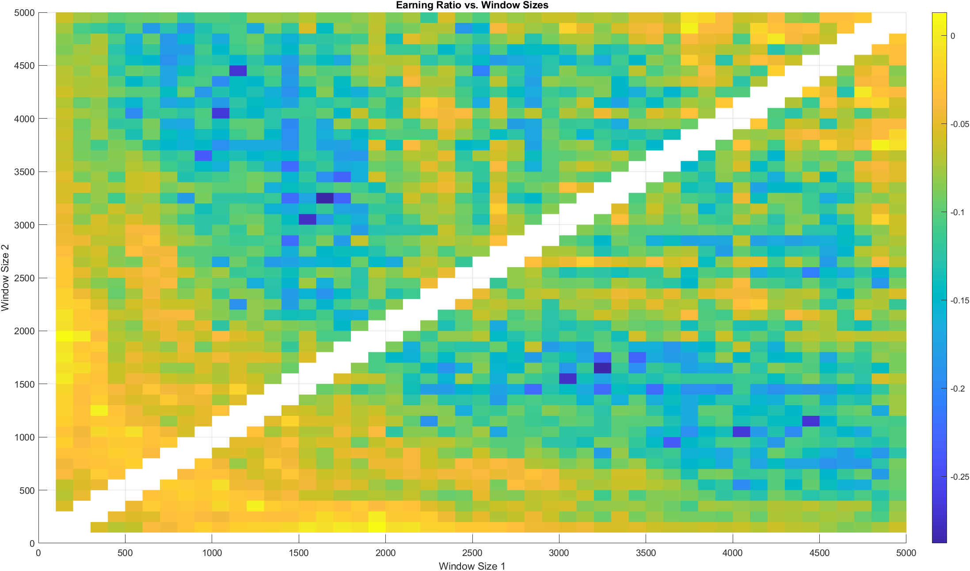

QQQ241209P525000
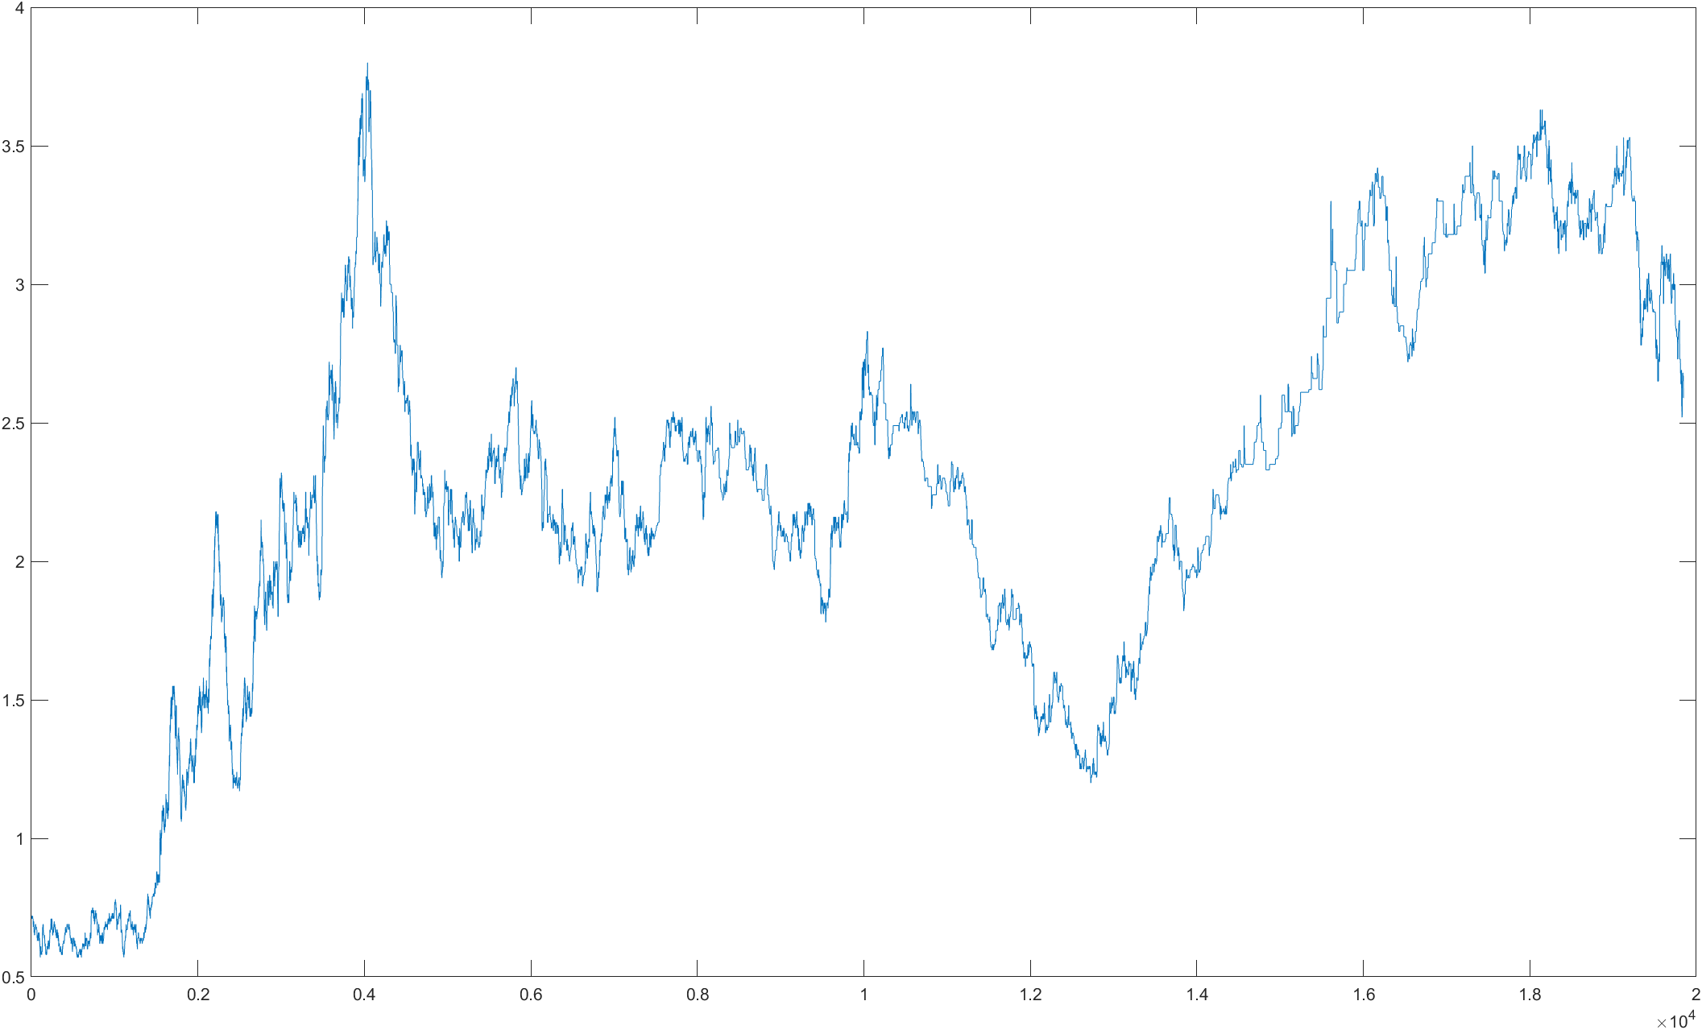
Doing density analysis of MA crossing gaps
Simple vs simple (messy as always)
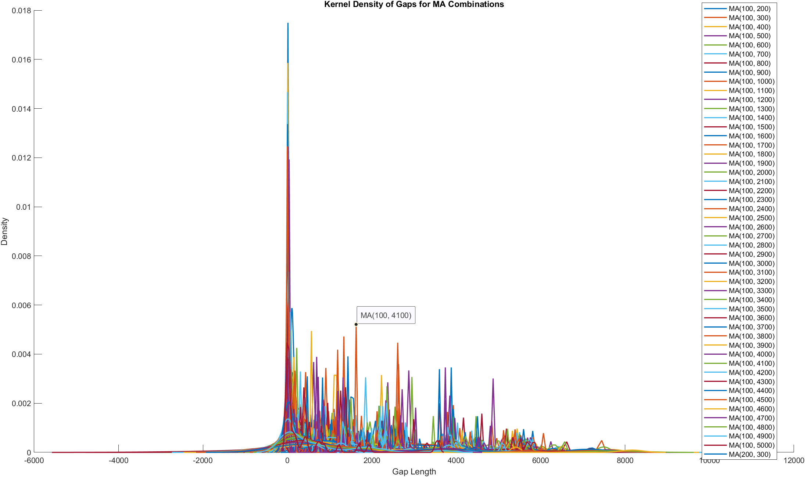

Linear vs linear (it seems 100 vs ~2000 yields the most wanted distribution)
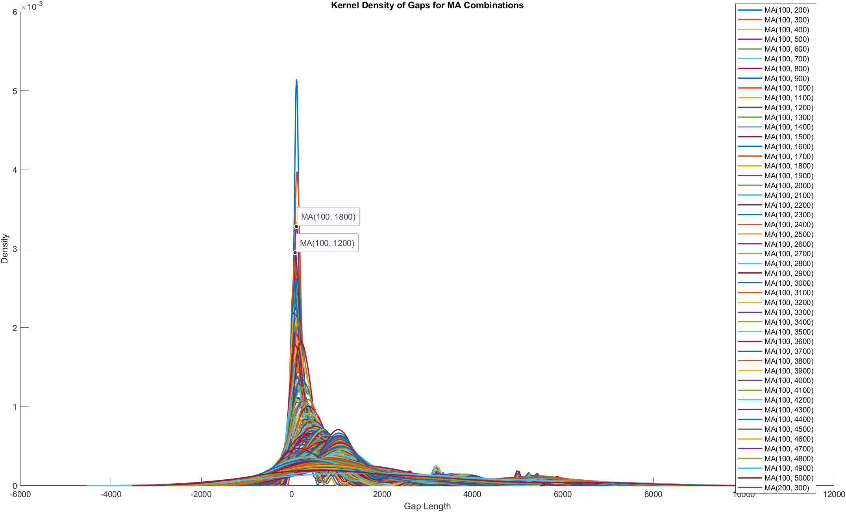
Square vs square (quite similar to above)
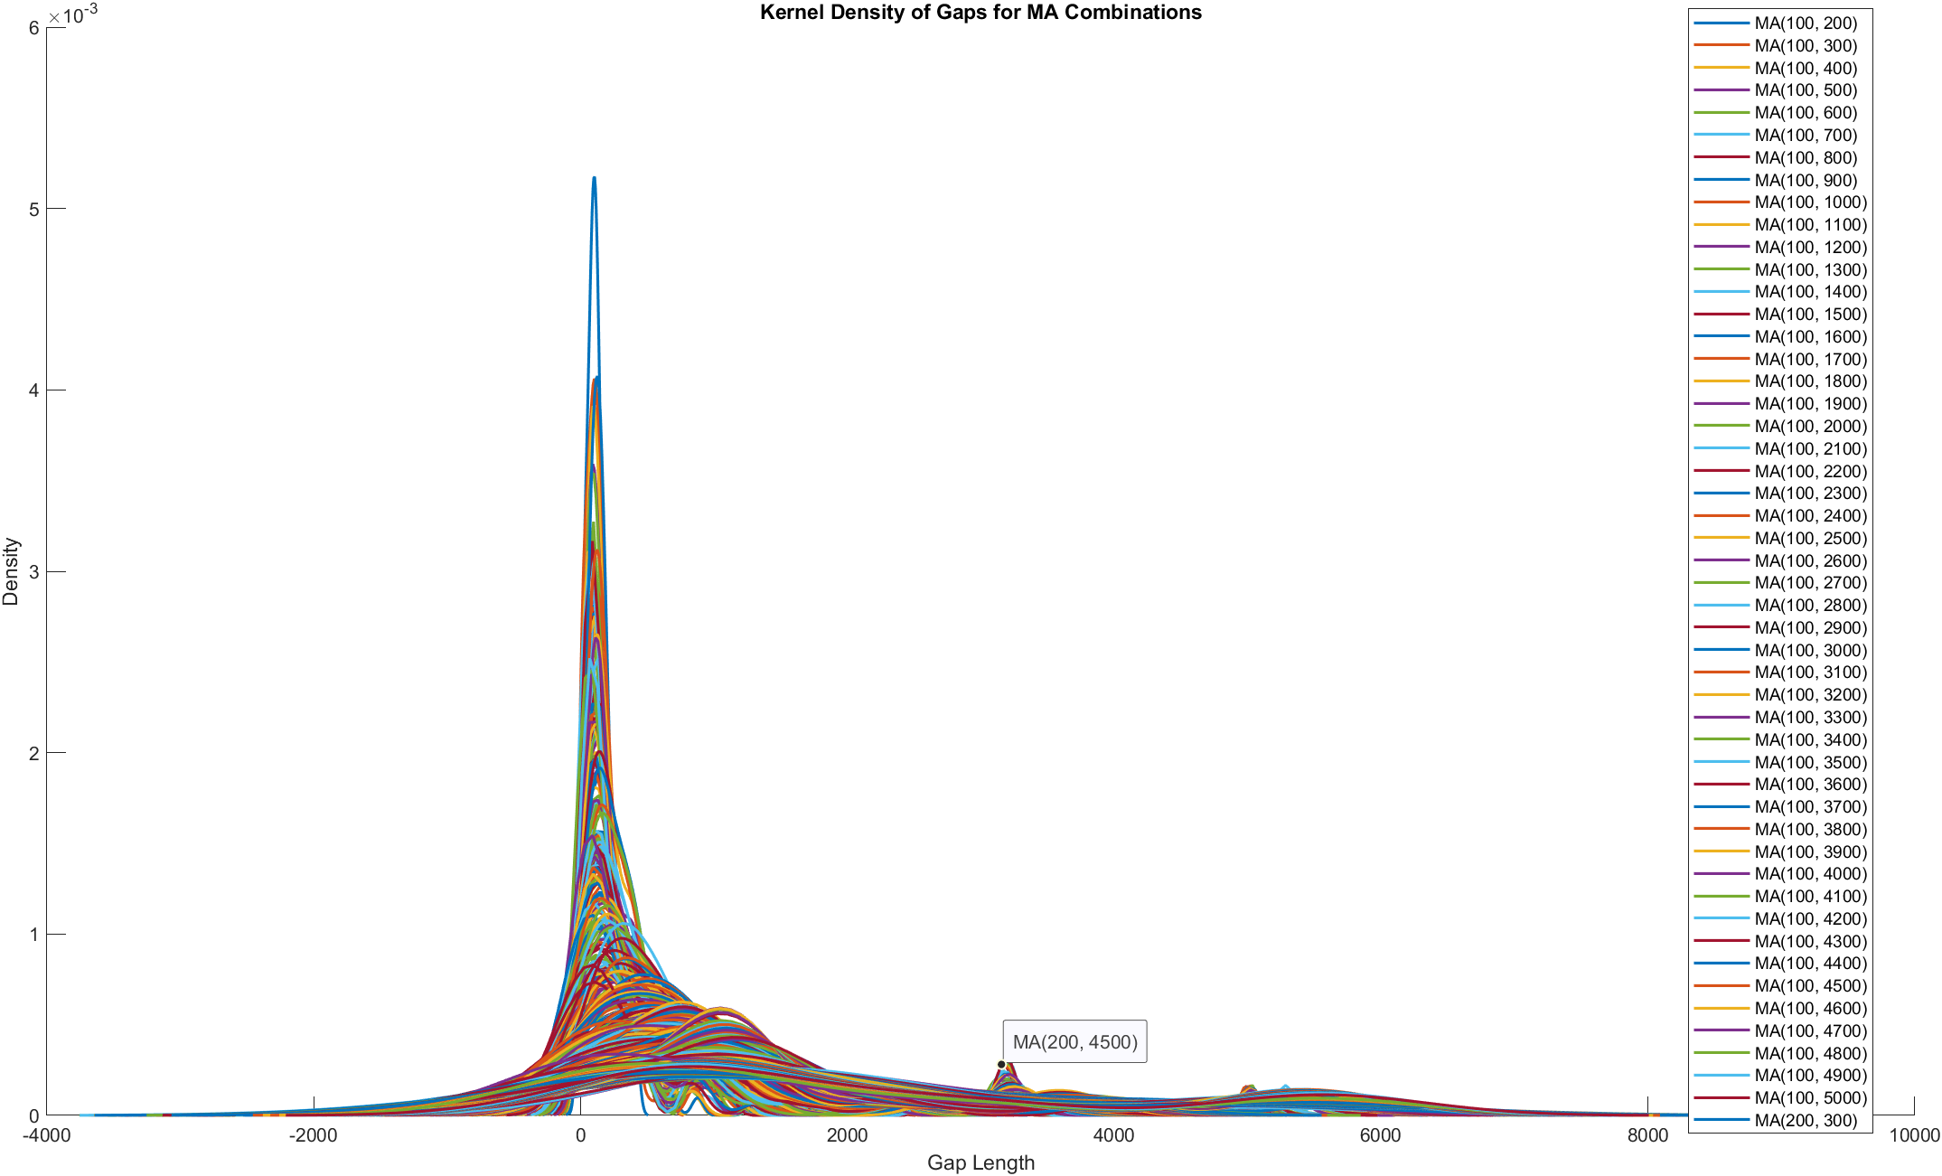

SMMA vs SMMA (a little more diverse, first tip for 100 vs ~1k, second tip for 100 vs ~3k)
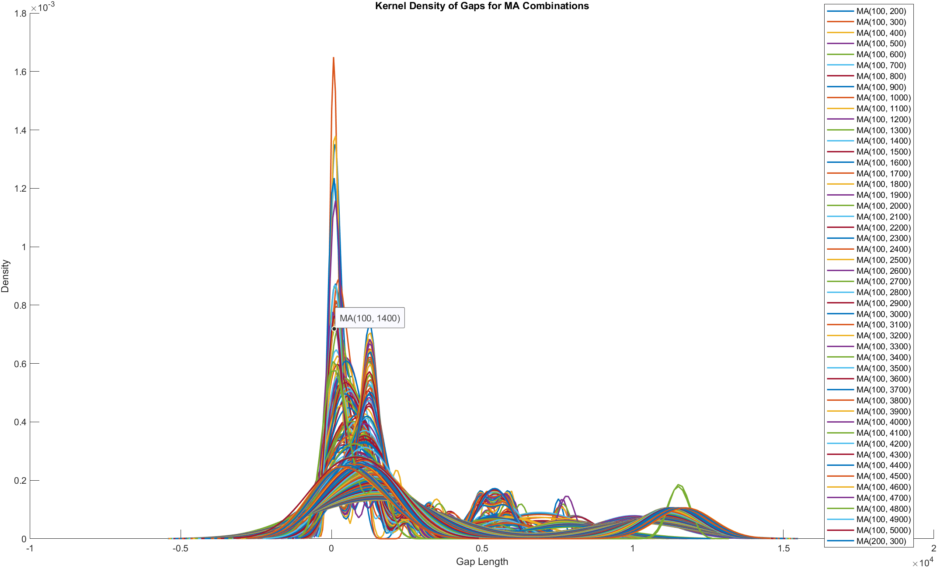
Graphs are similar for index ETF option MA crossing gaps, no matter C/P

NVDA241213C145000 linear vs linear
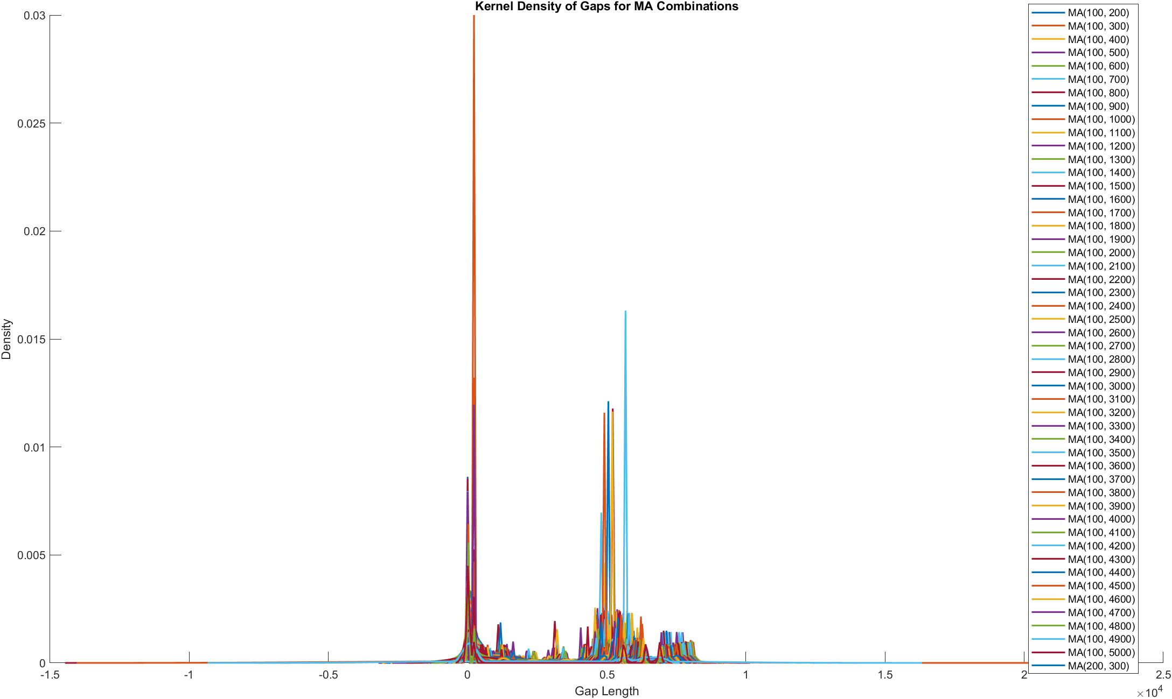
NVDA241213P135000 linear vs linear
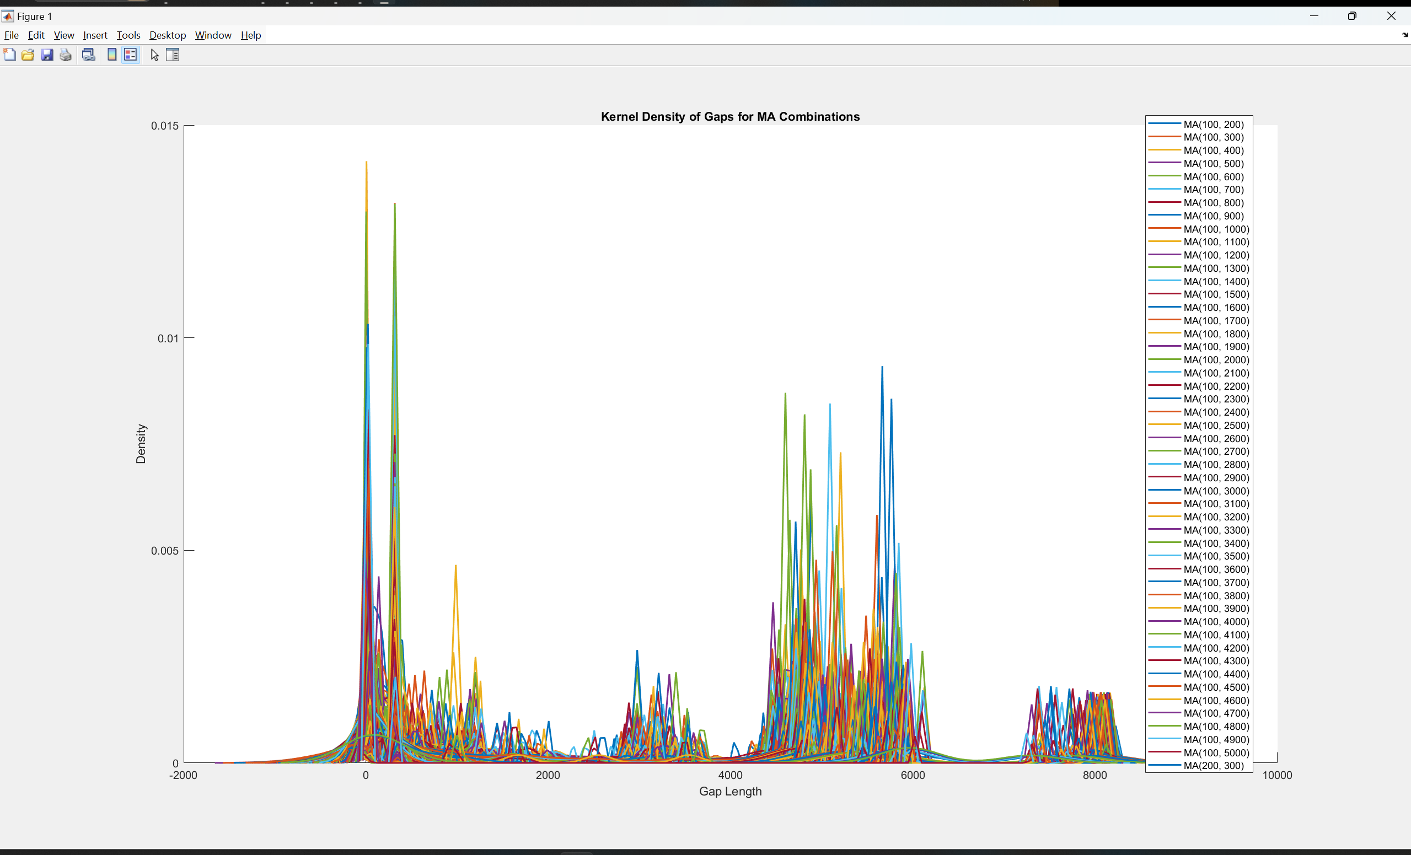
MA of last price vs MA of bid/ask
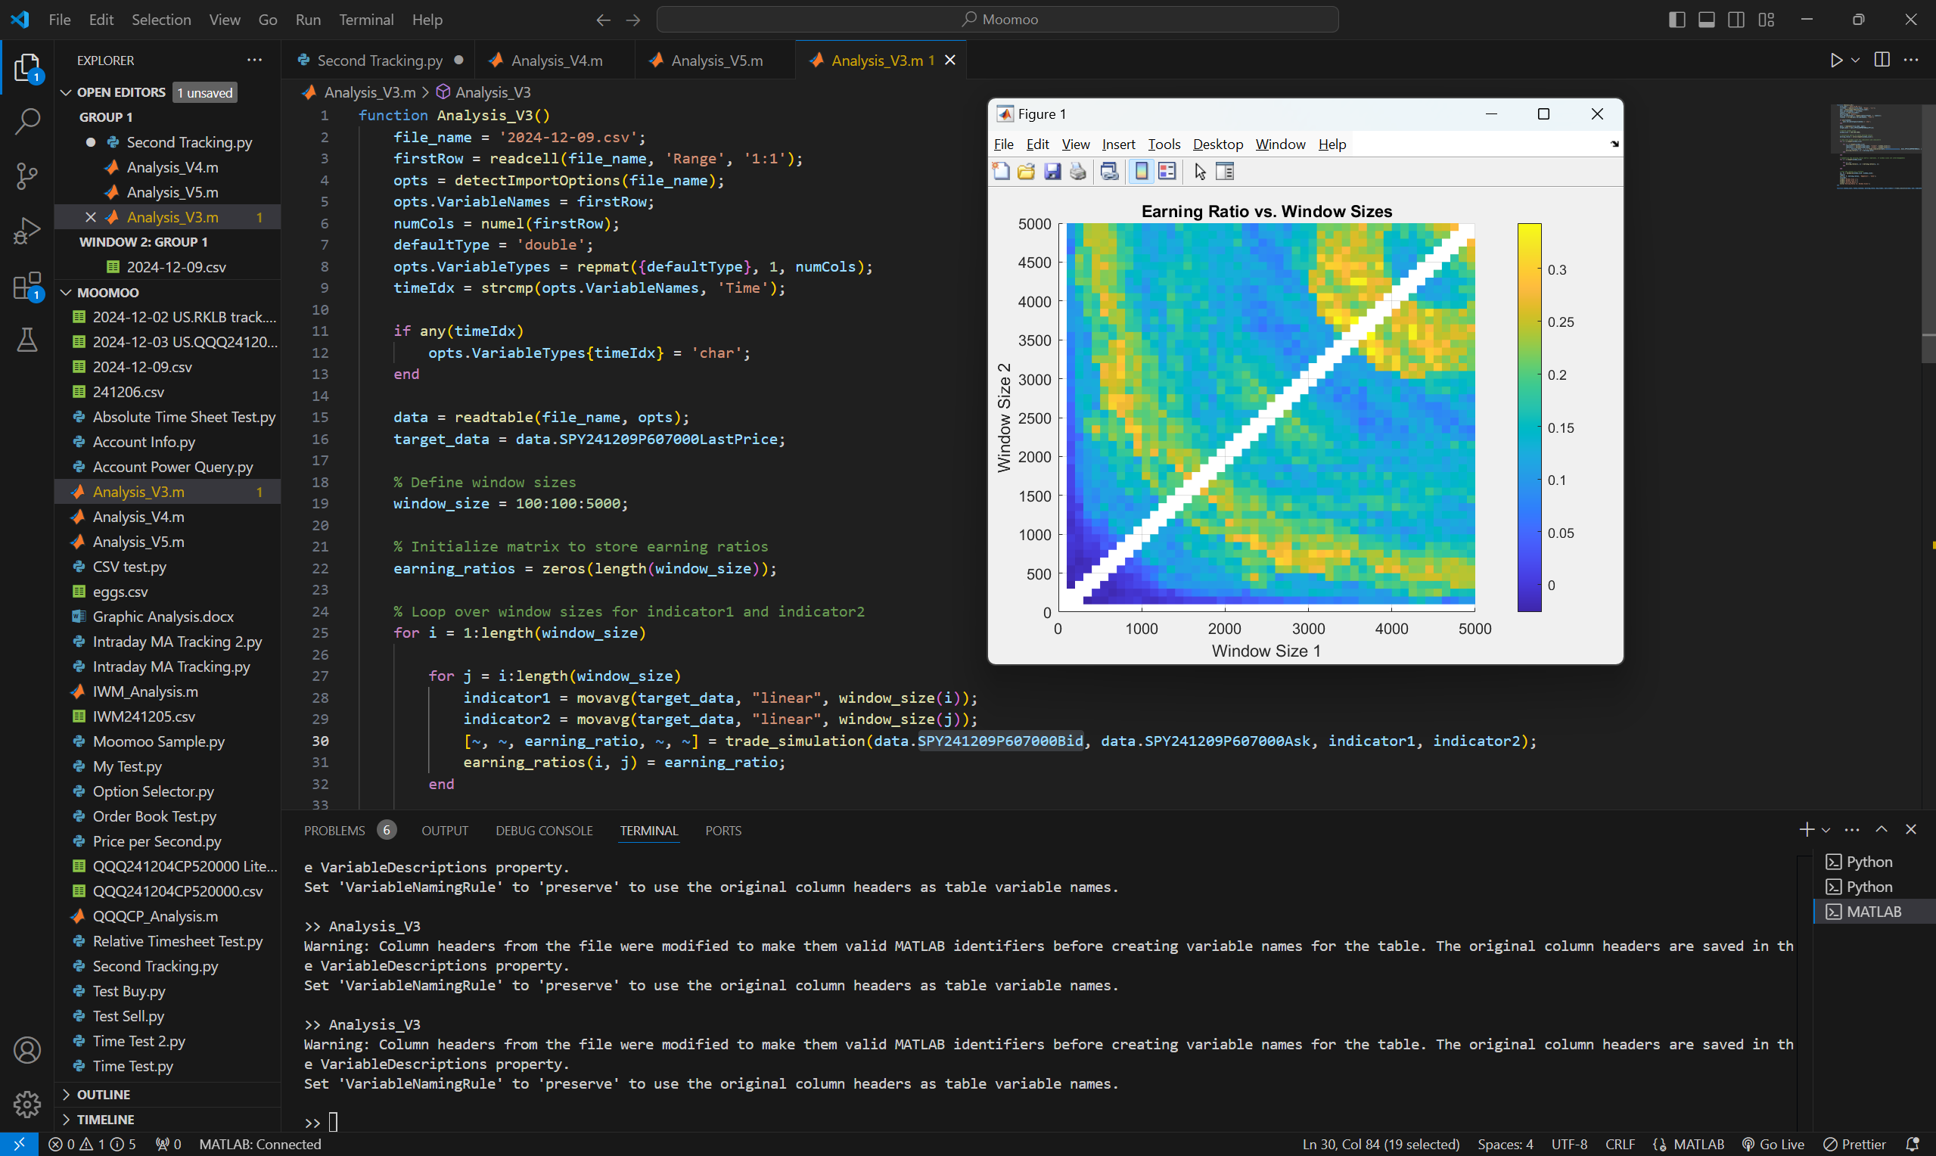
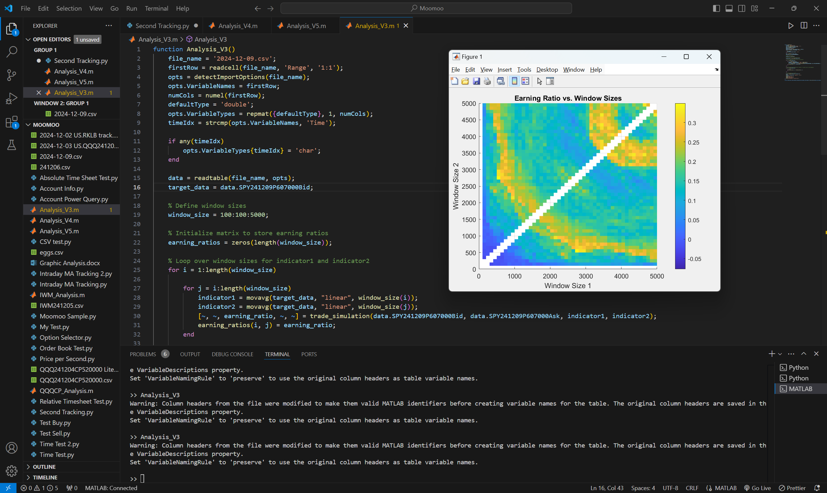

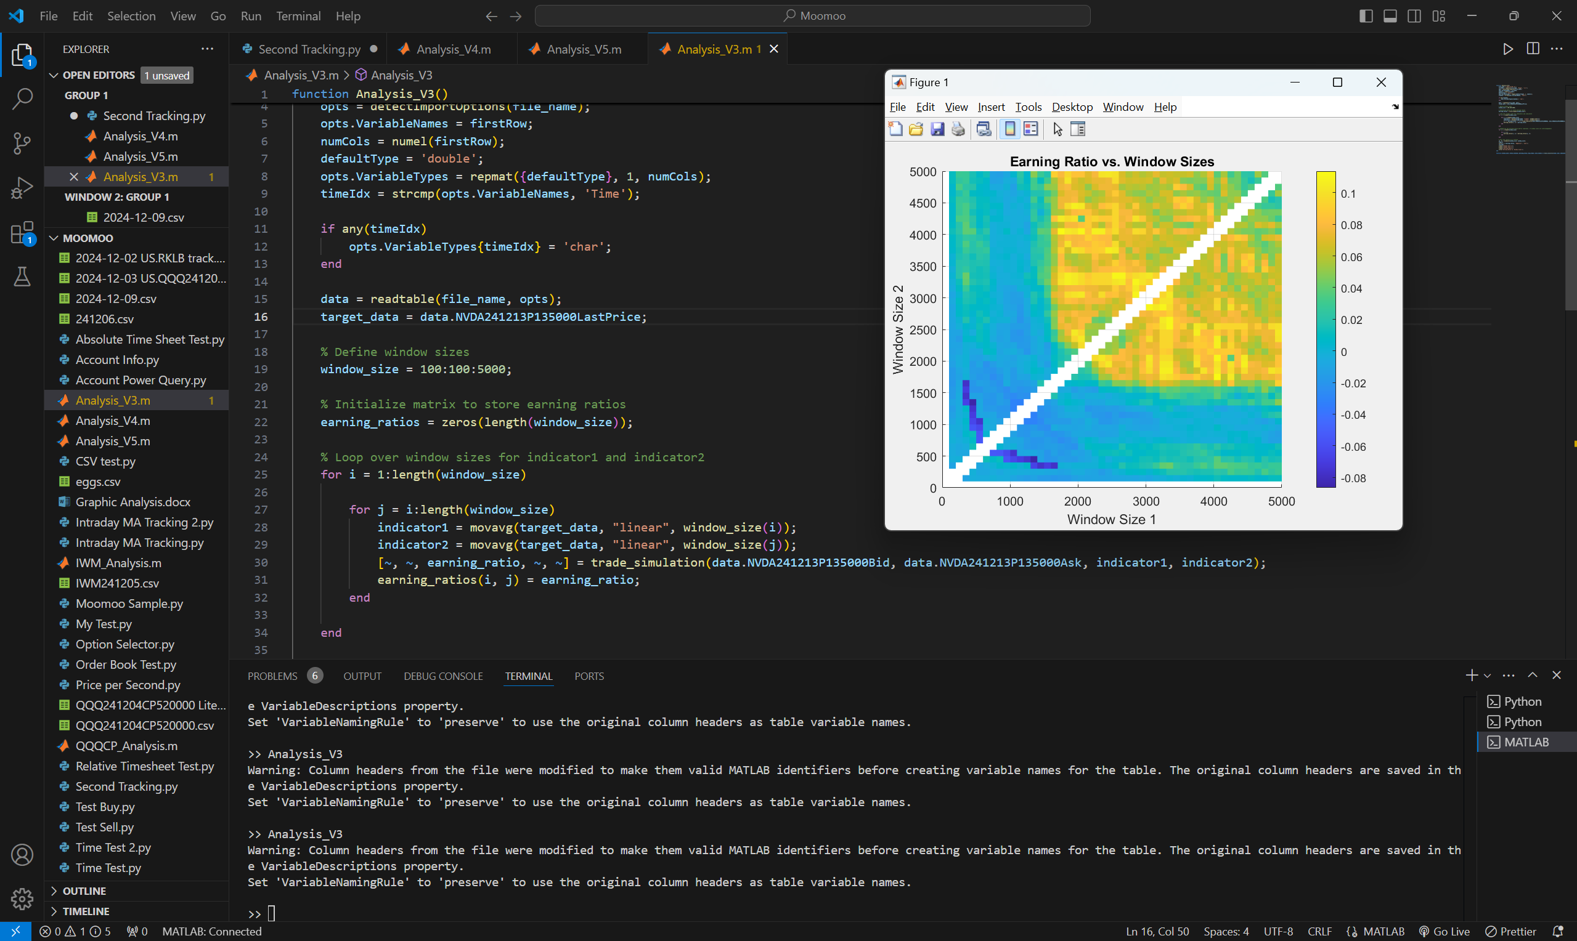
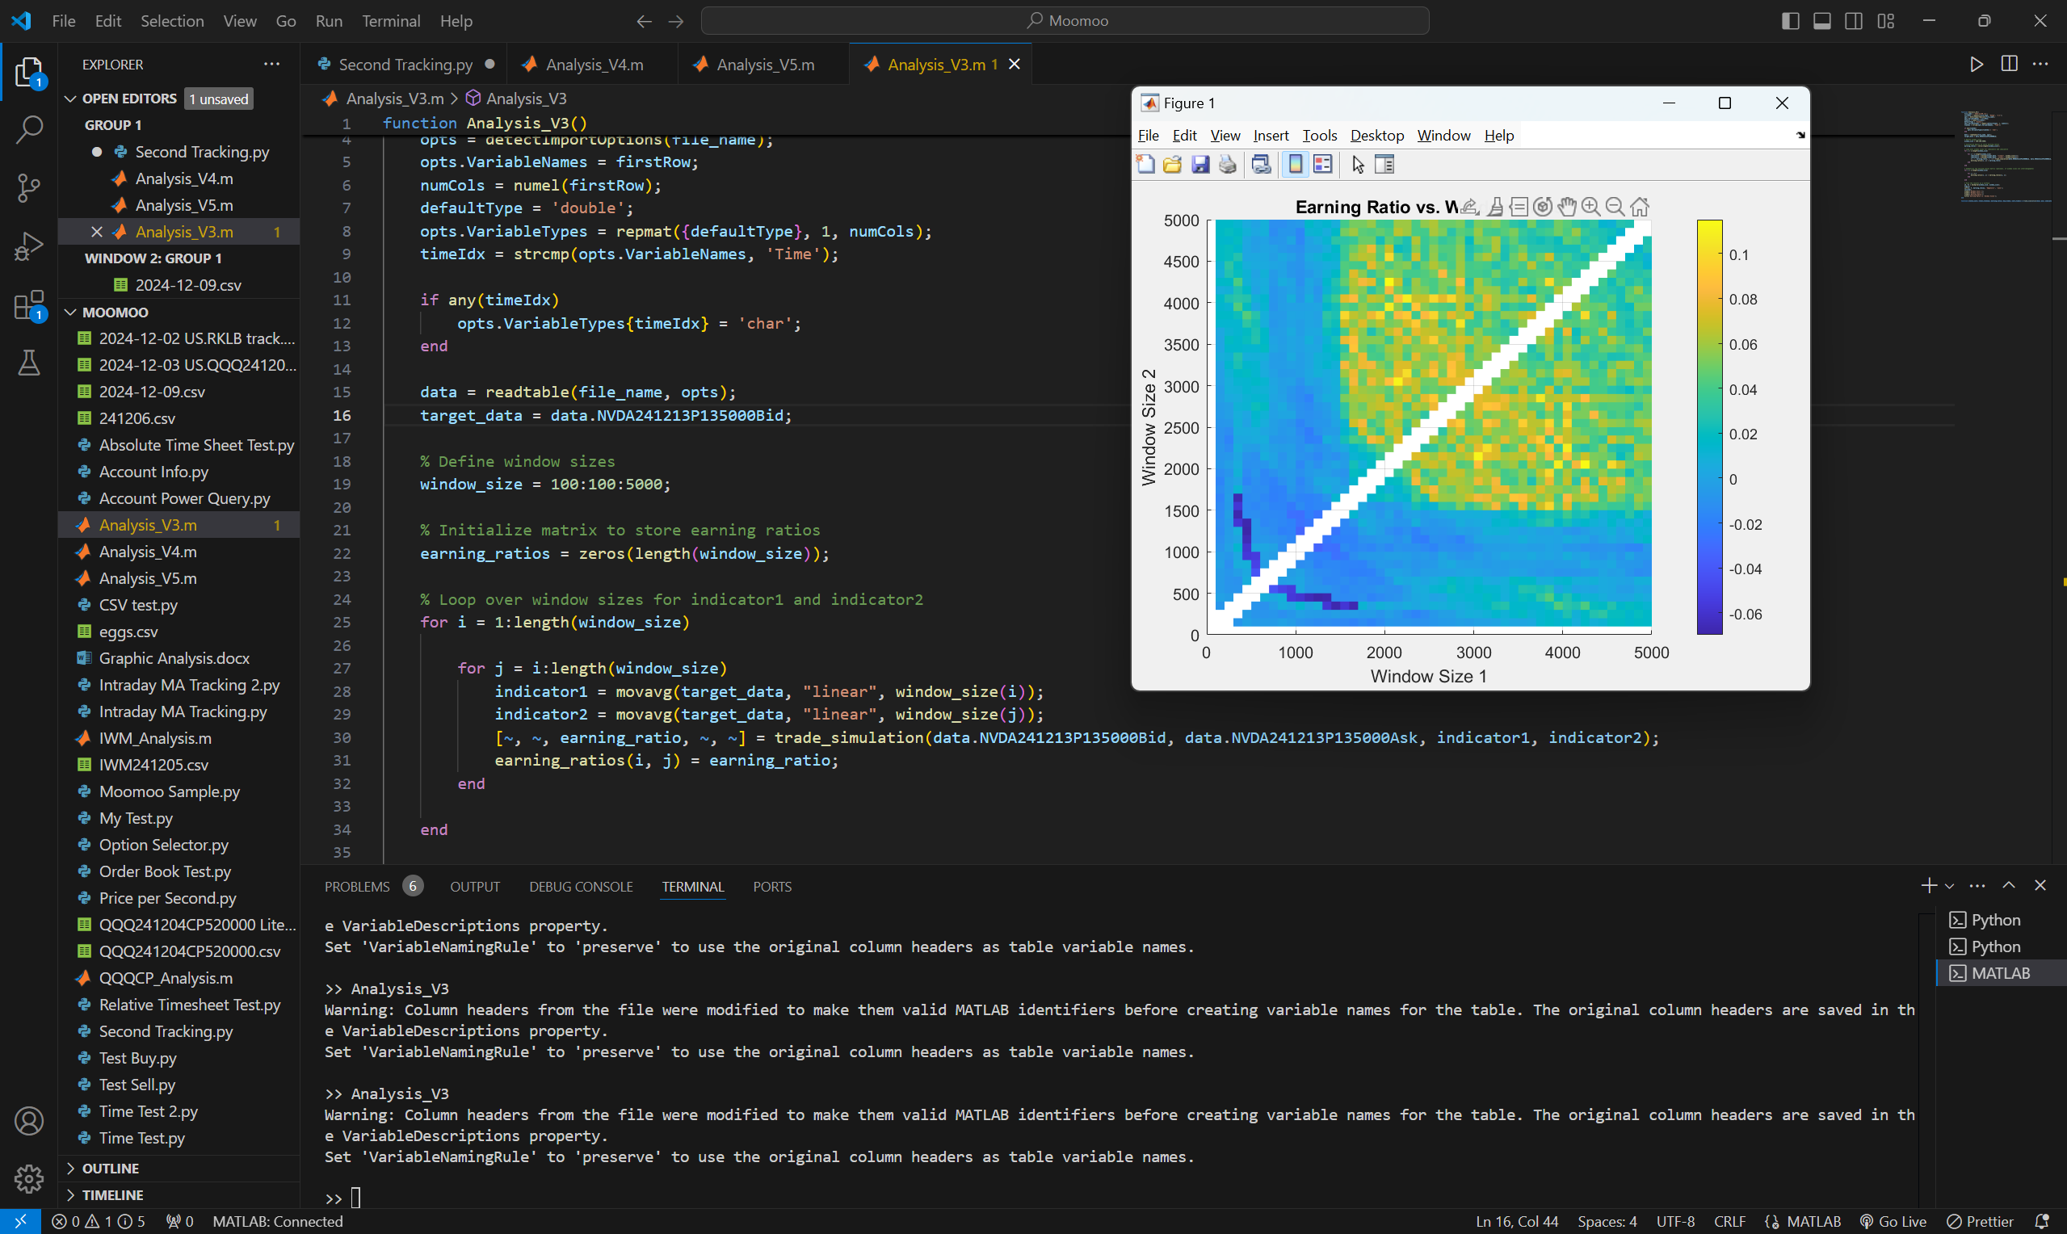

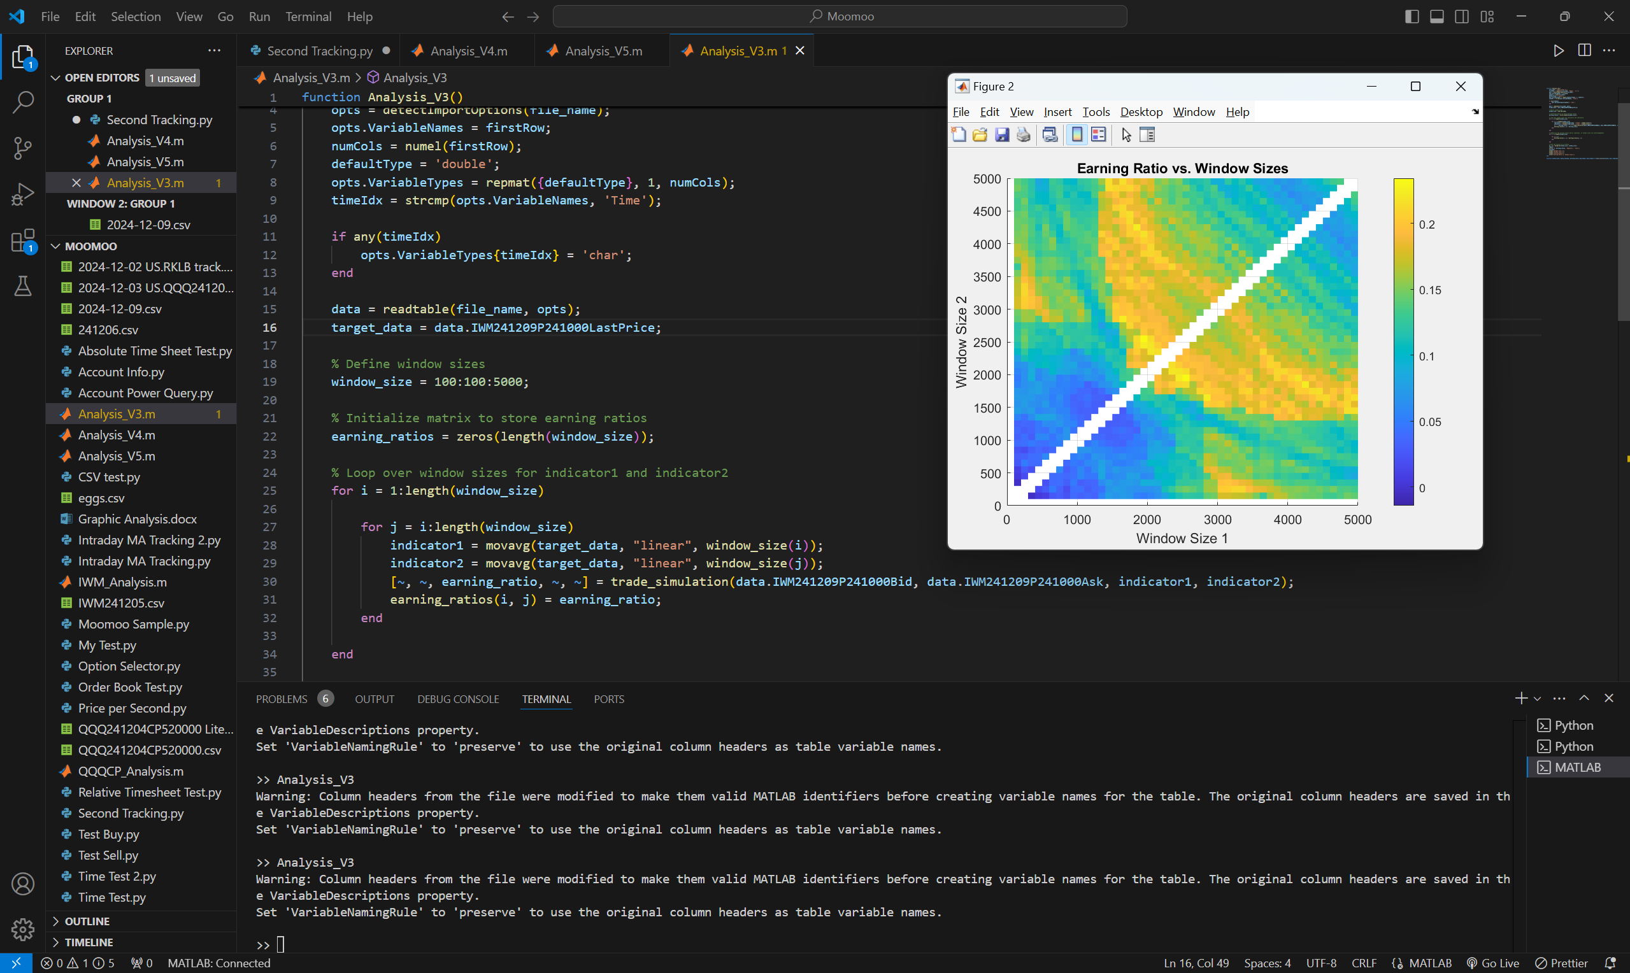
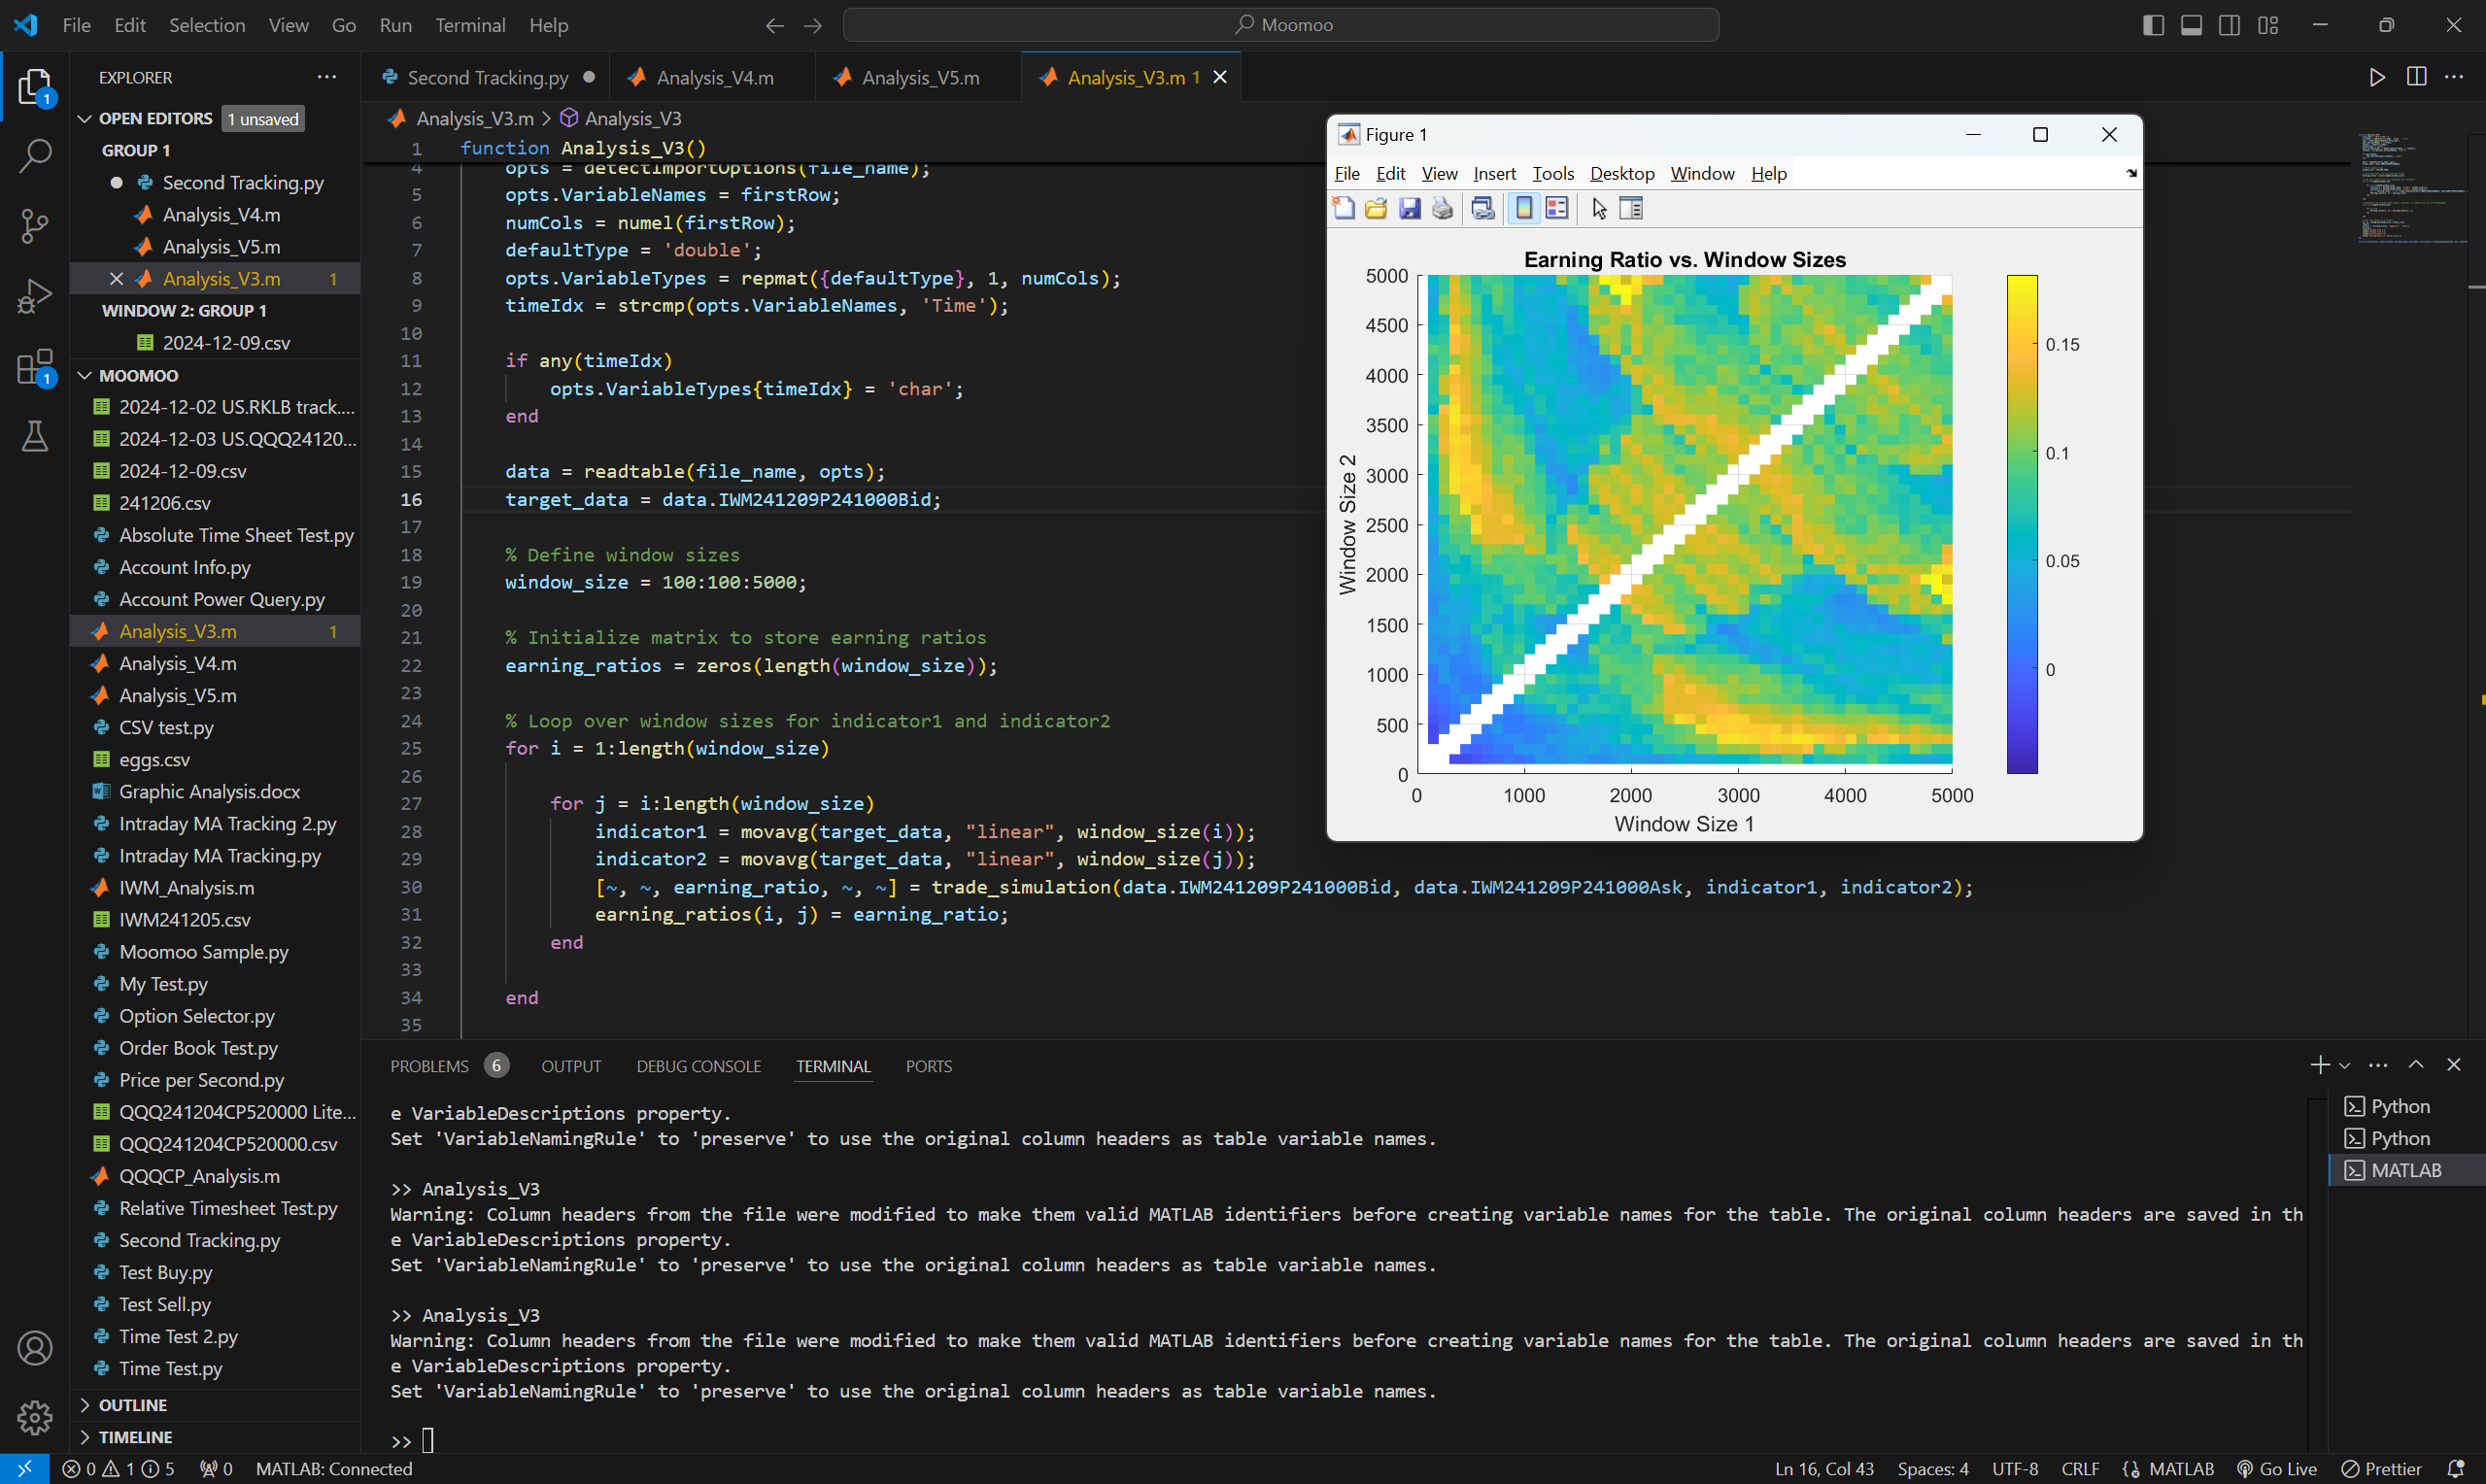

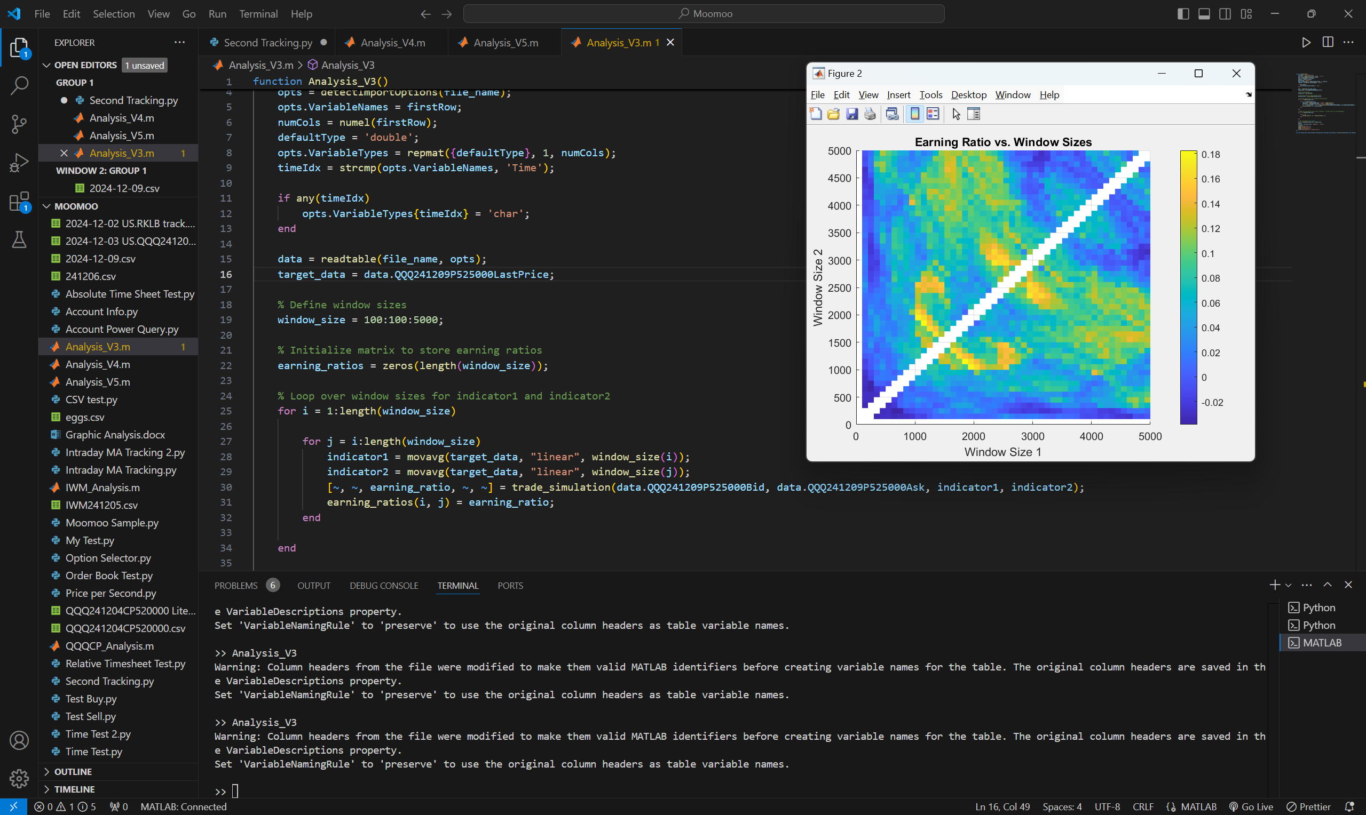
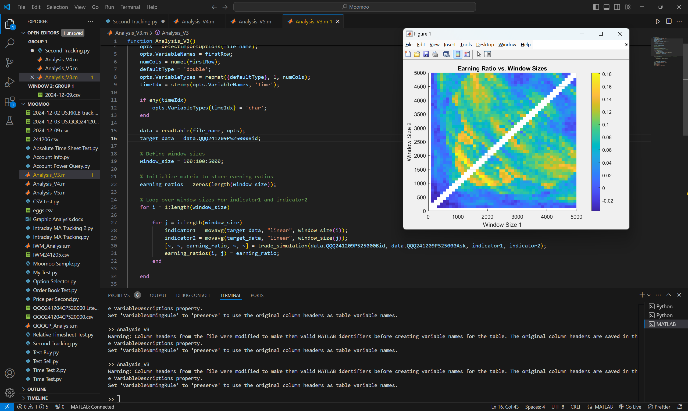

Trying 3MA strategy
NVDA241213C140
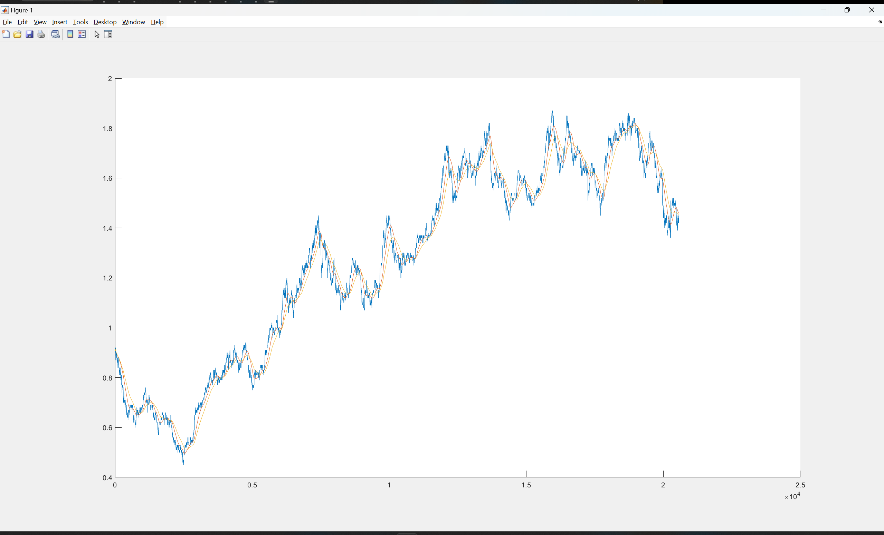
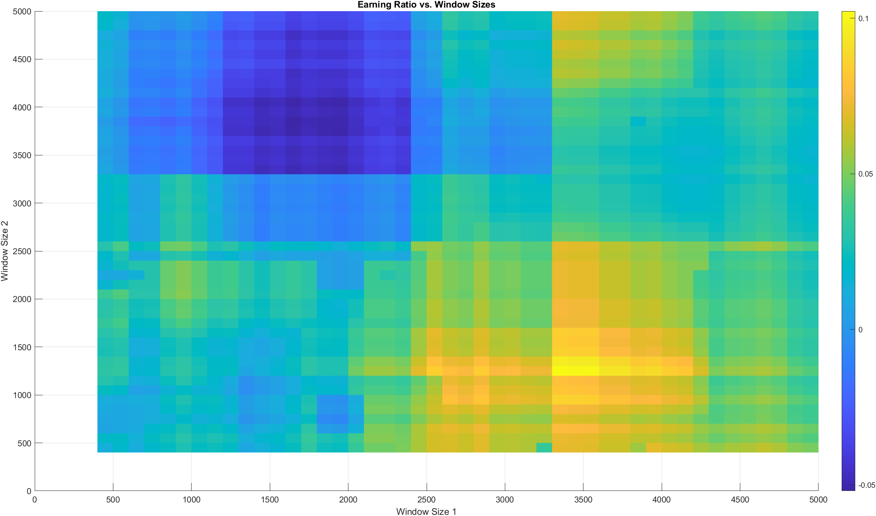

QQQ241211C528
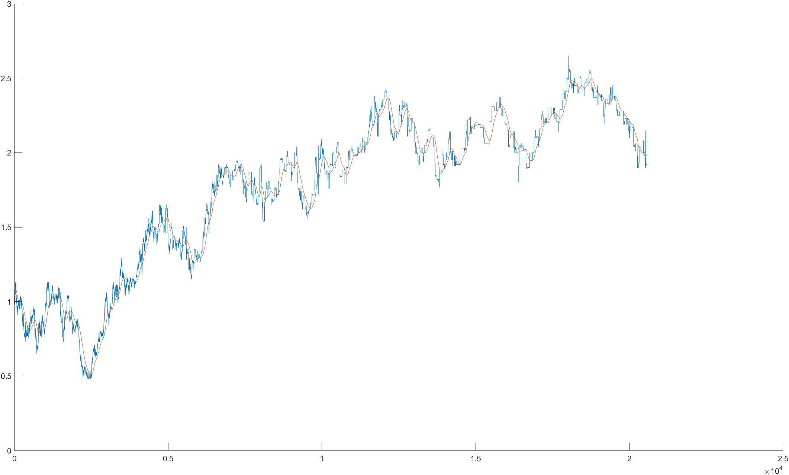
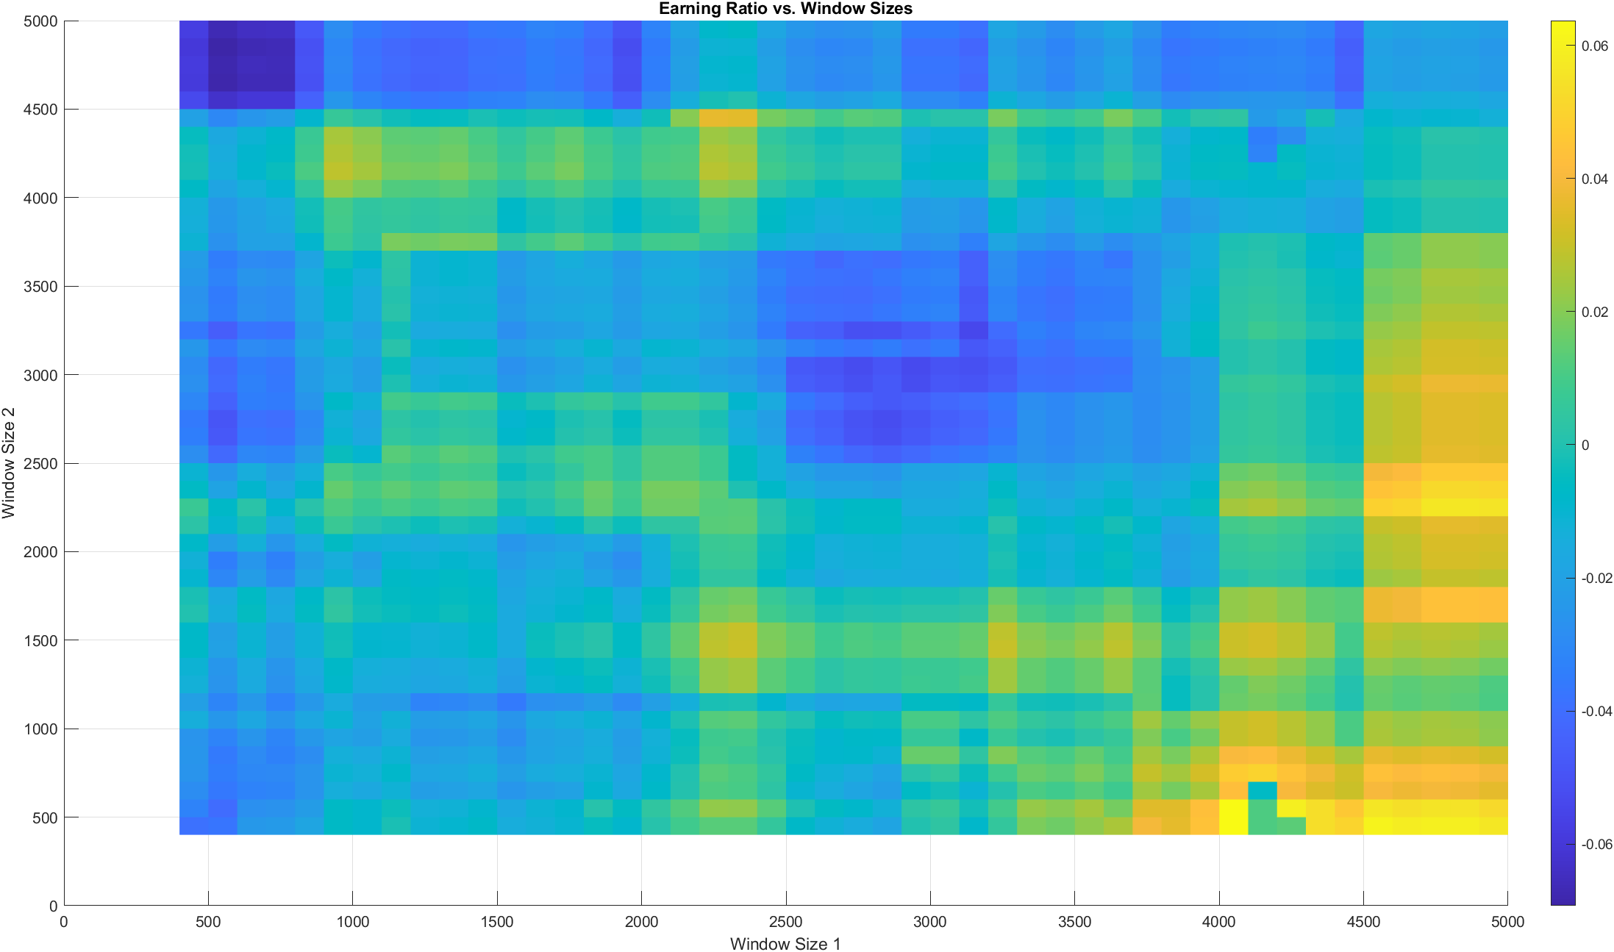

SPY241211C607
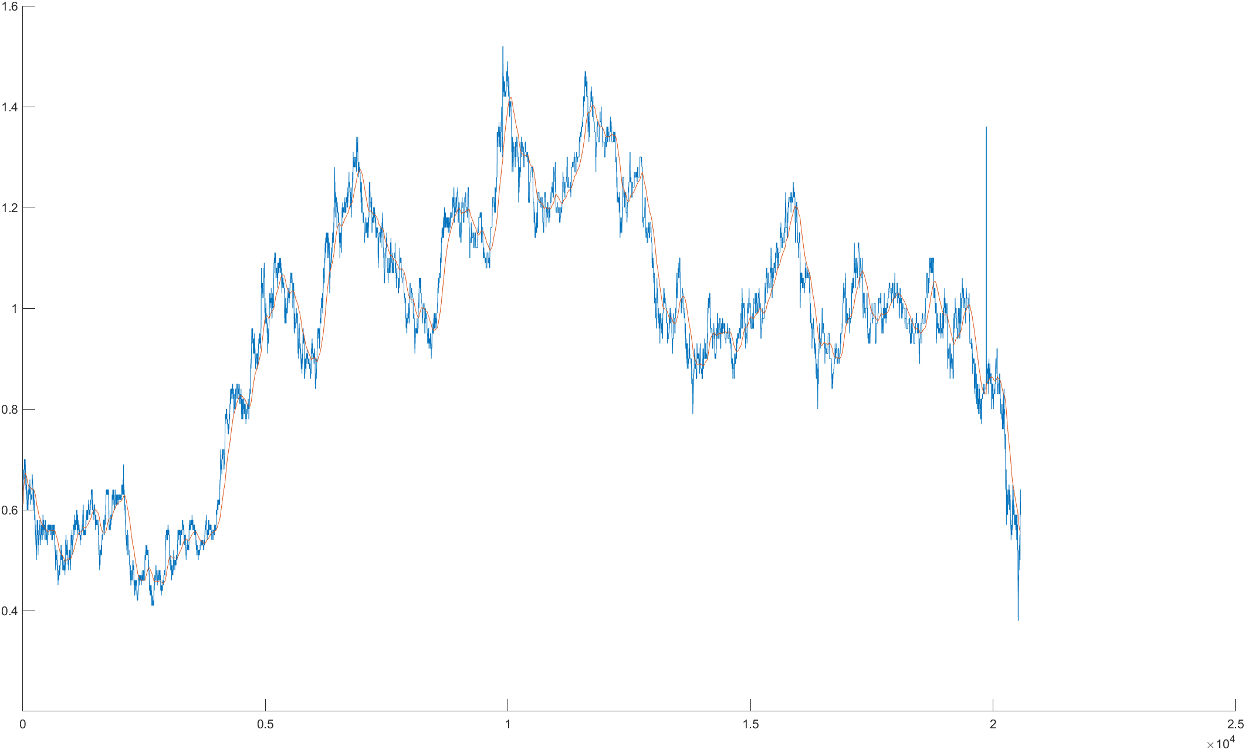
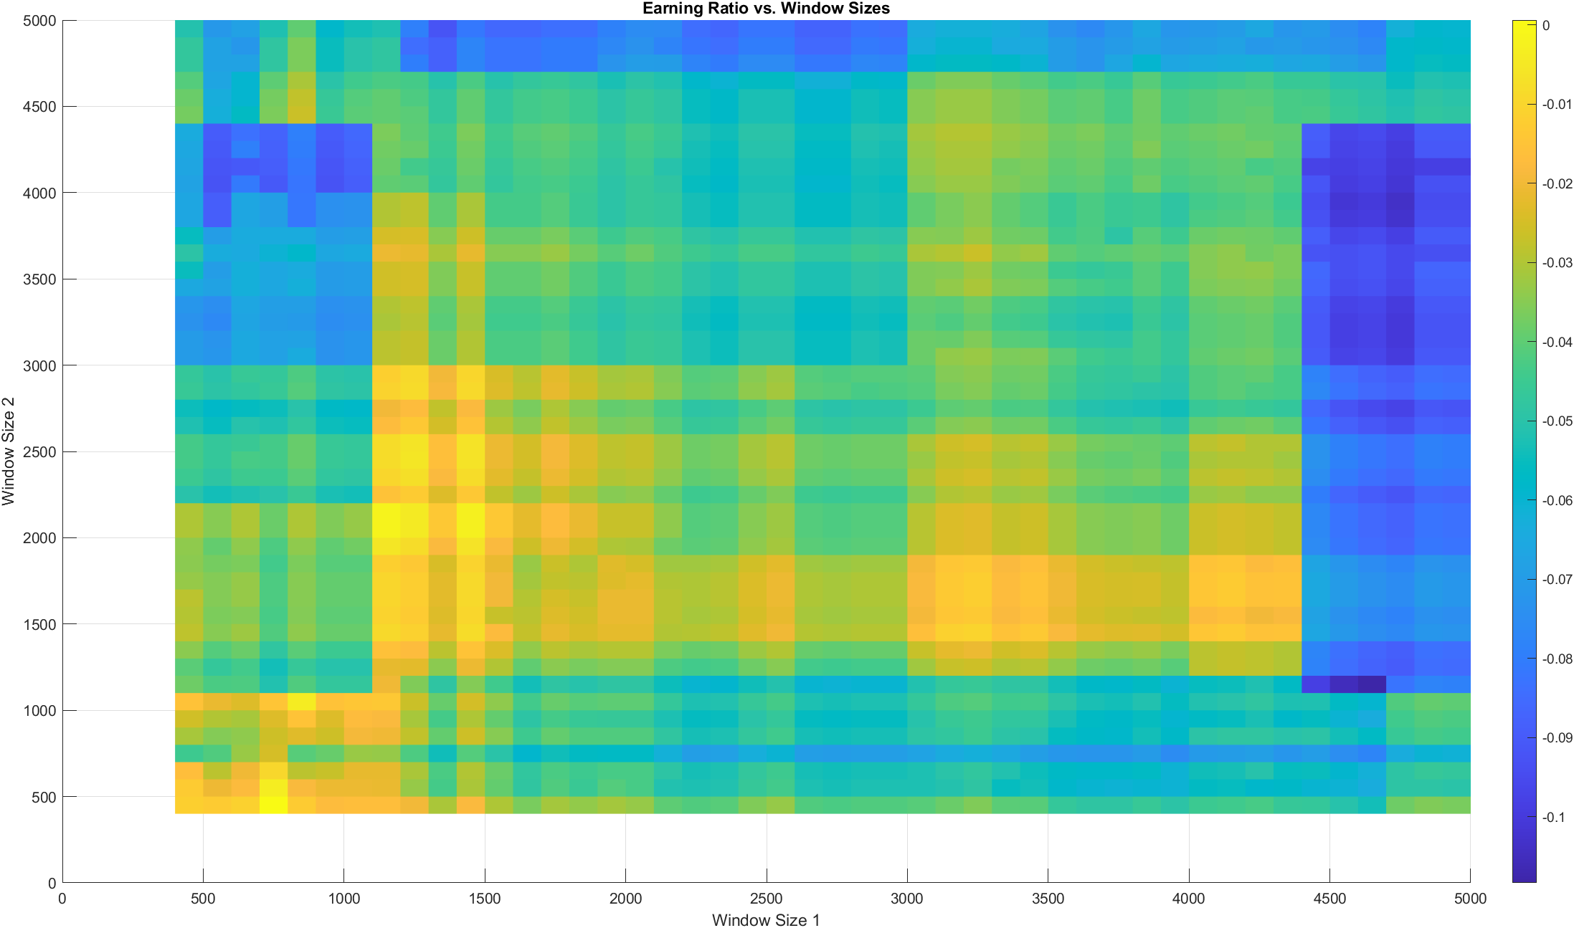

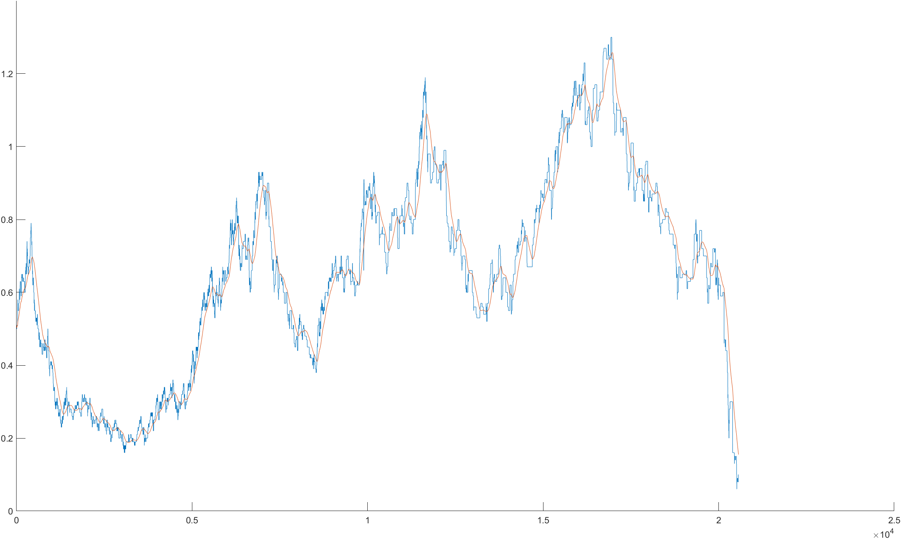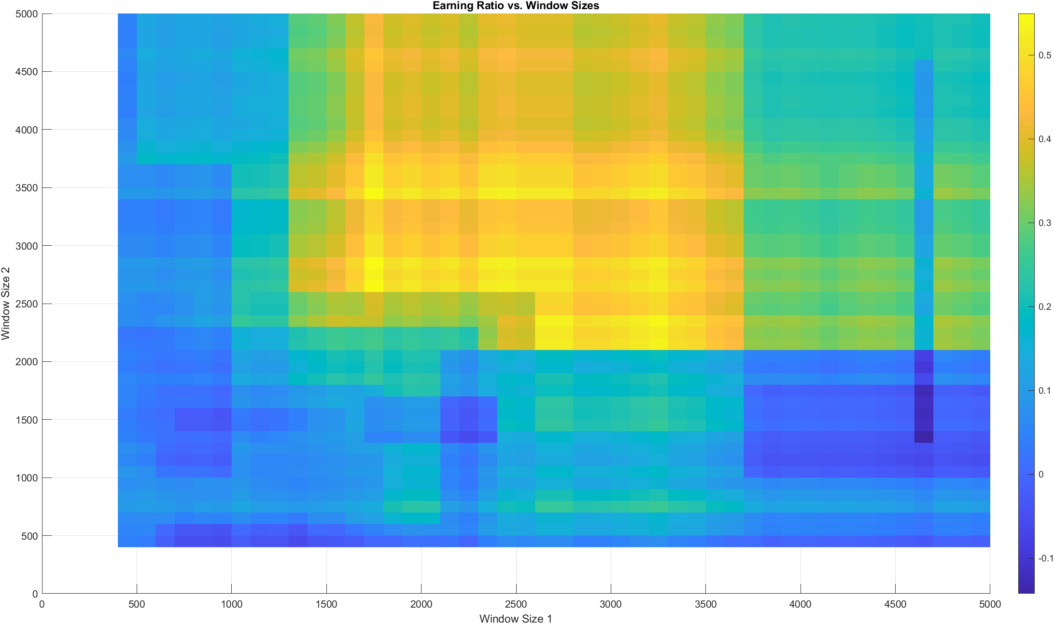

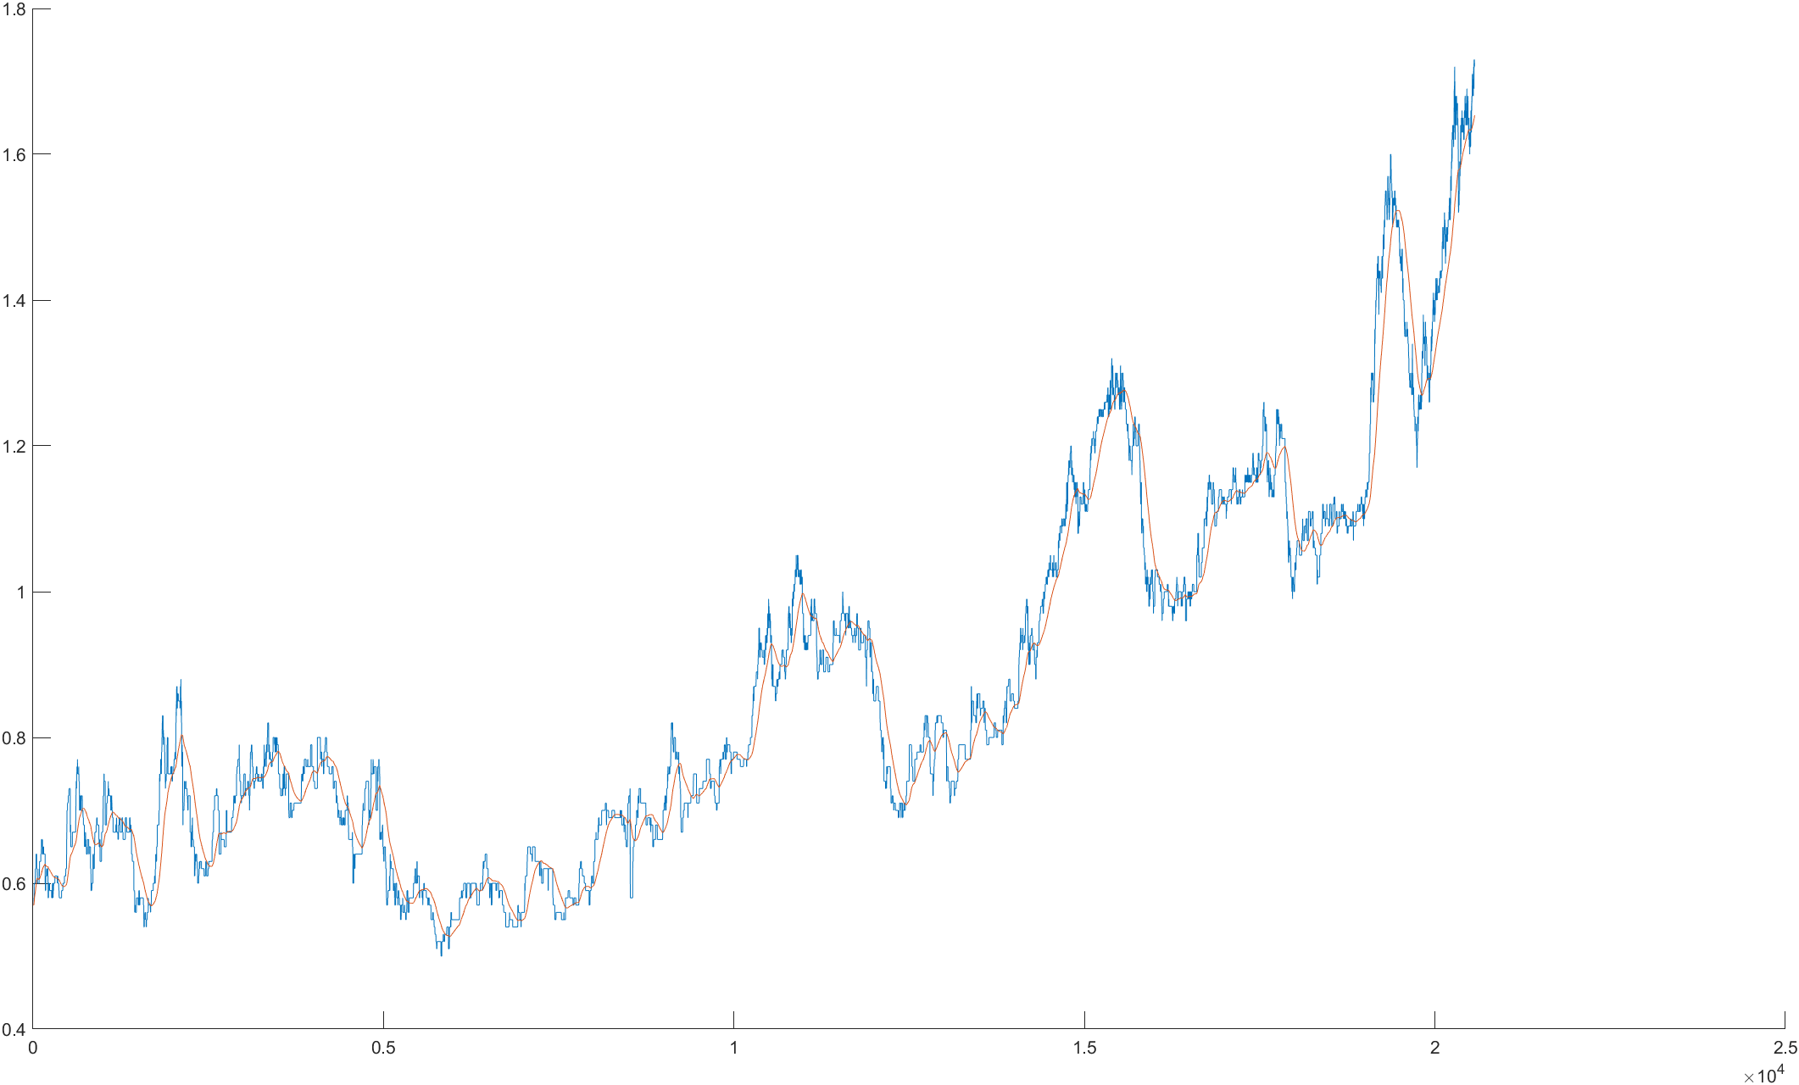
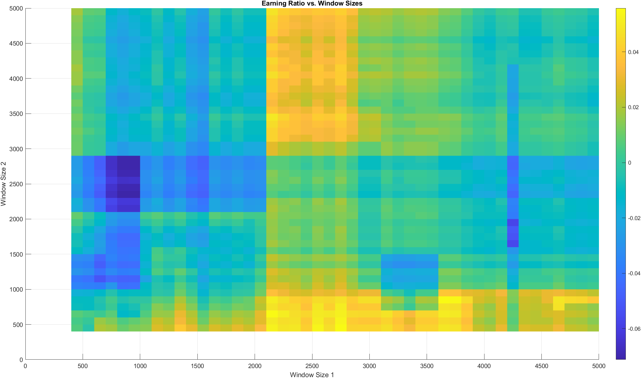

QQQ
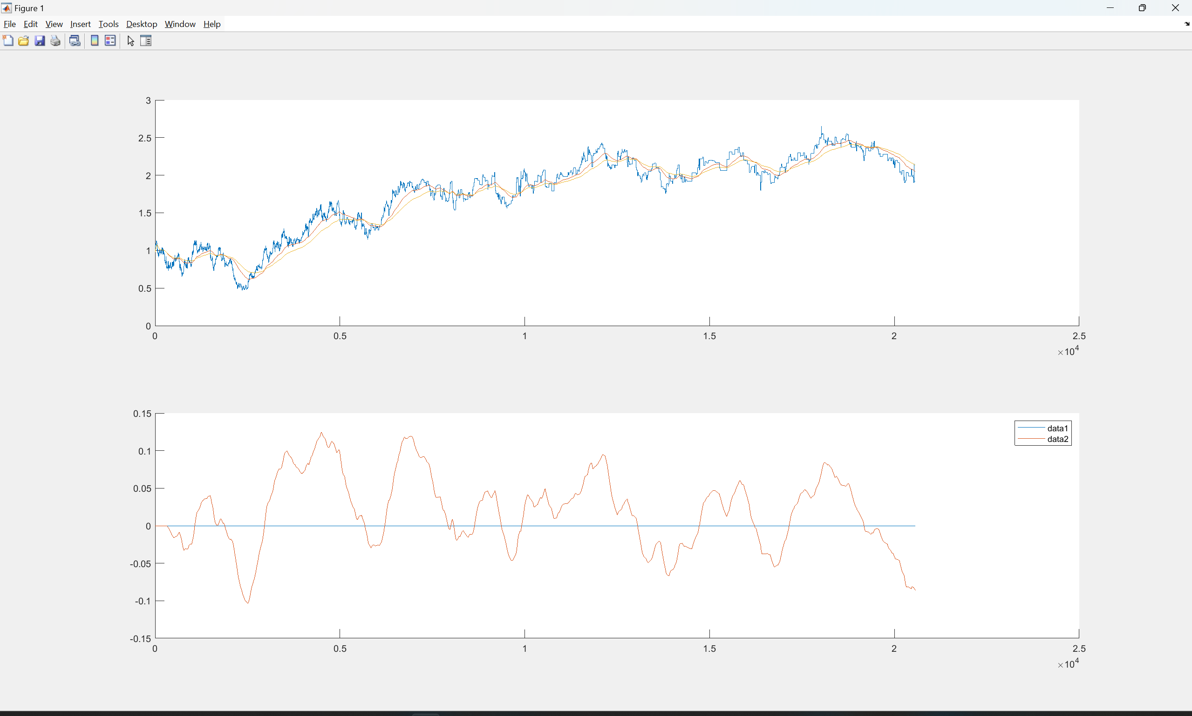
SPY
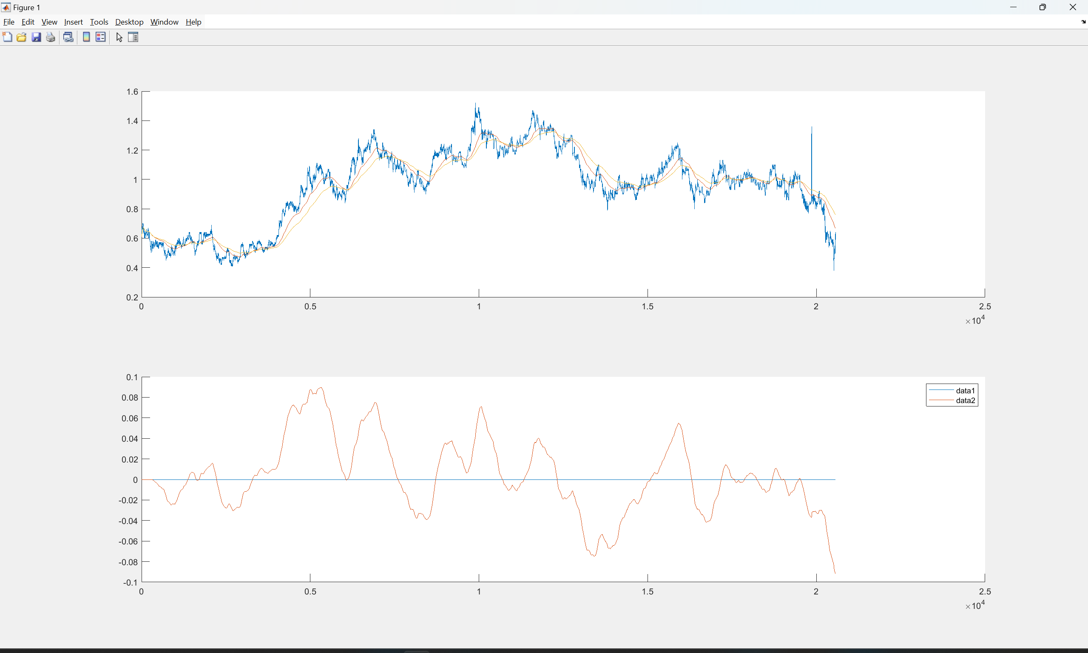
IWM
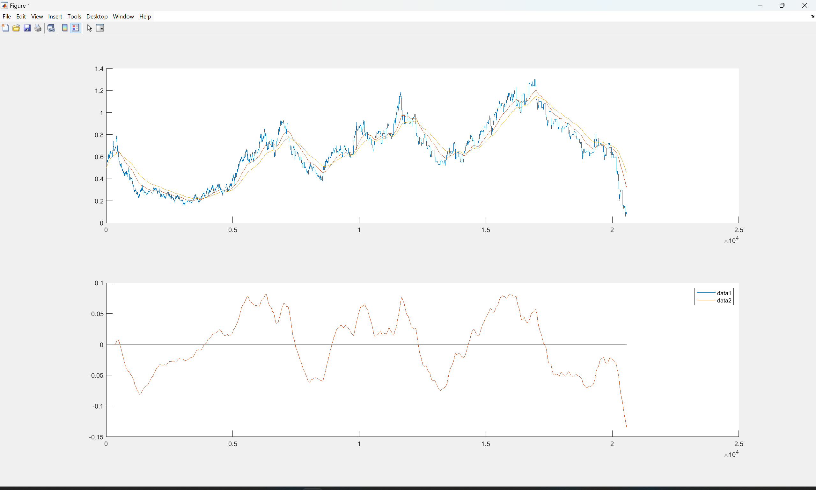
NVDA
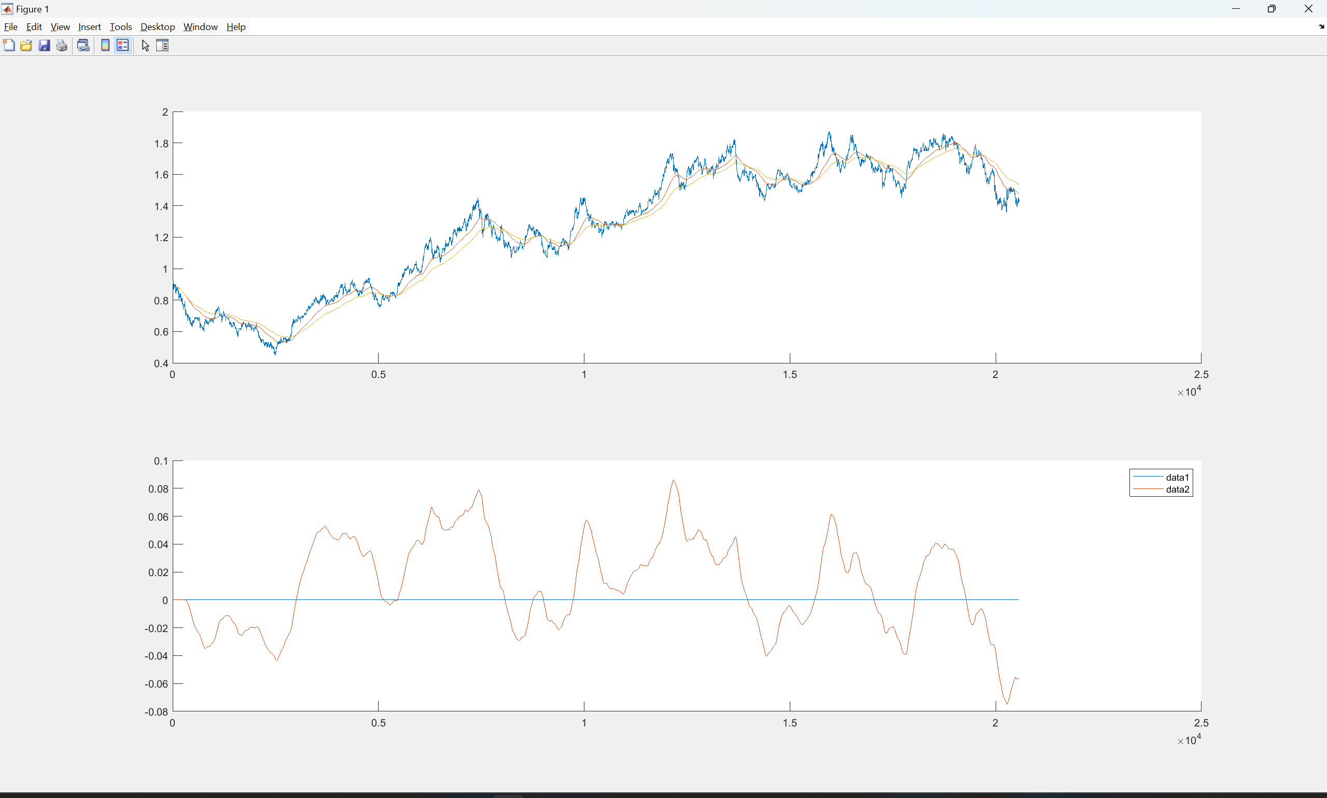
TSLA
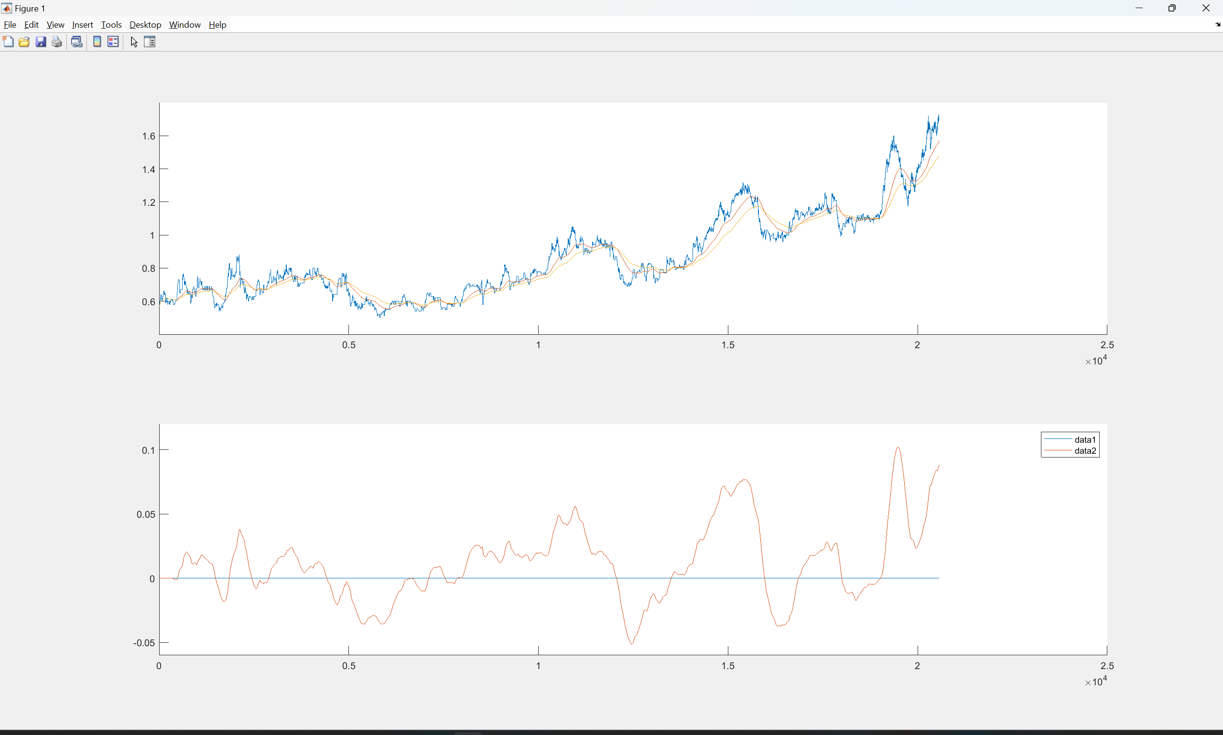
AAPL
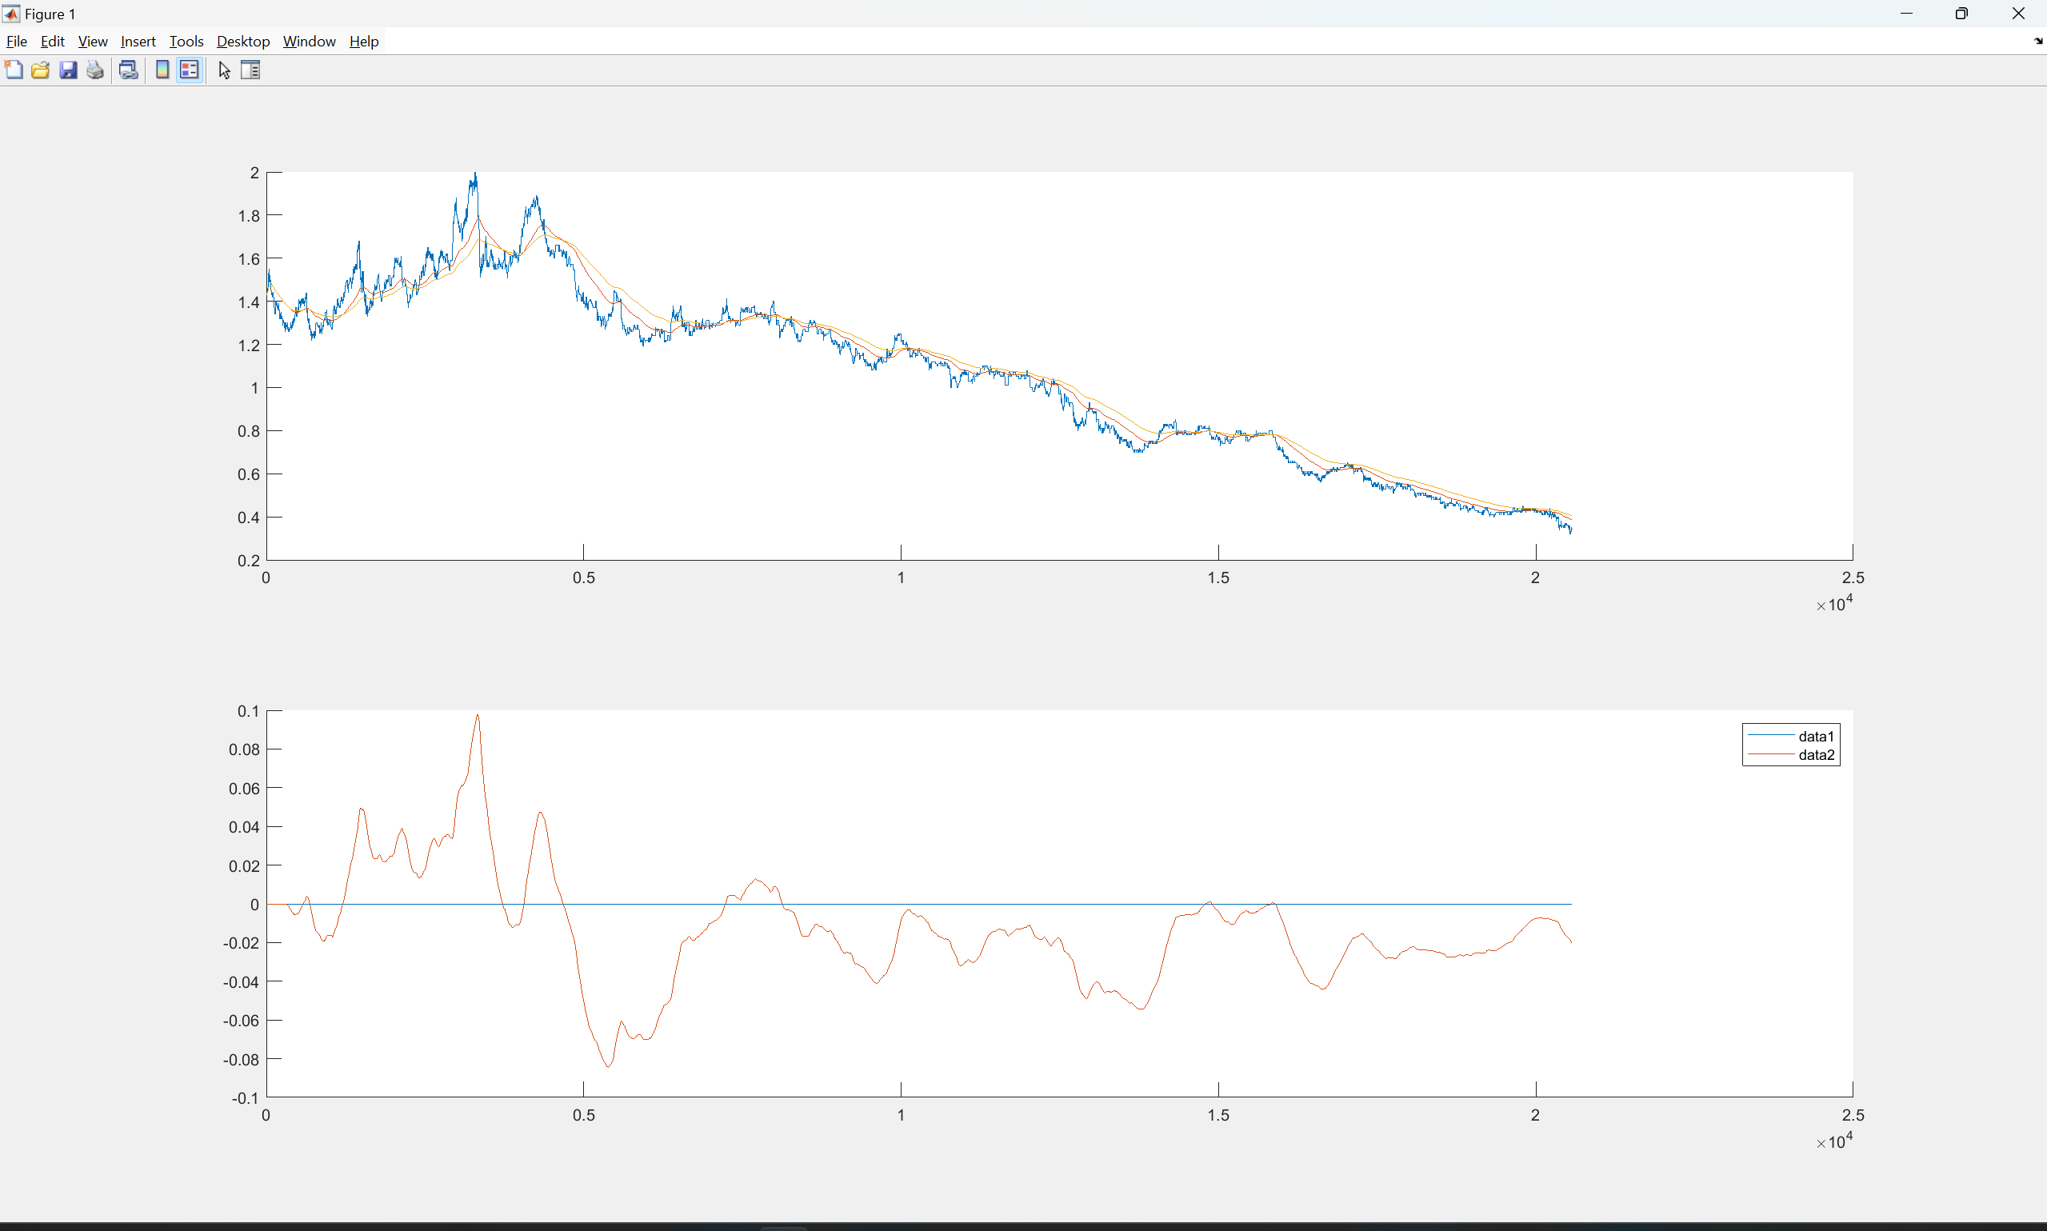
GOOGL
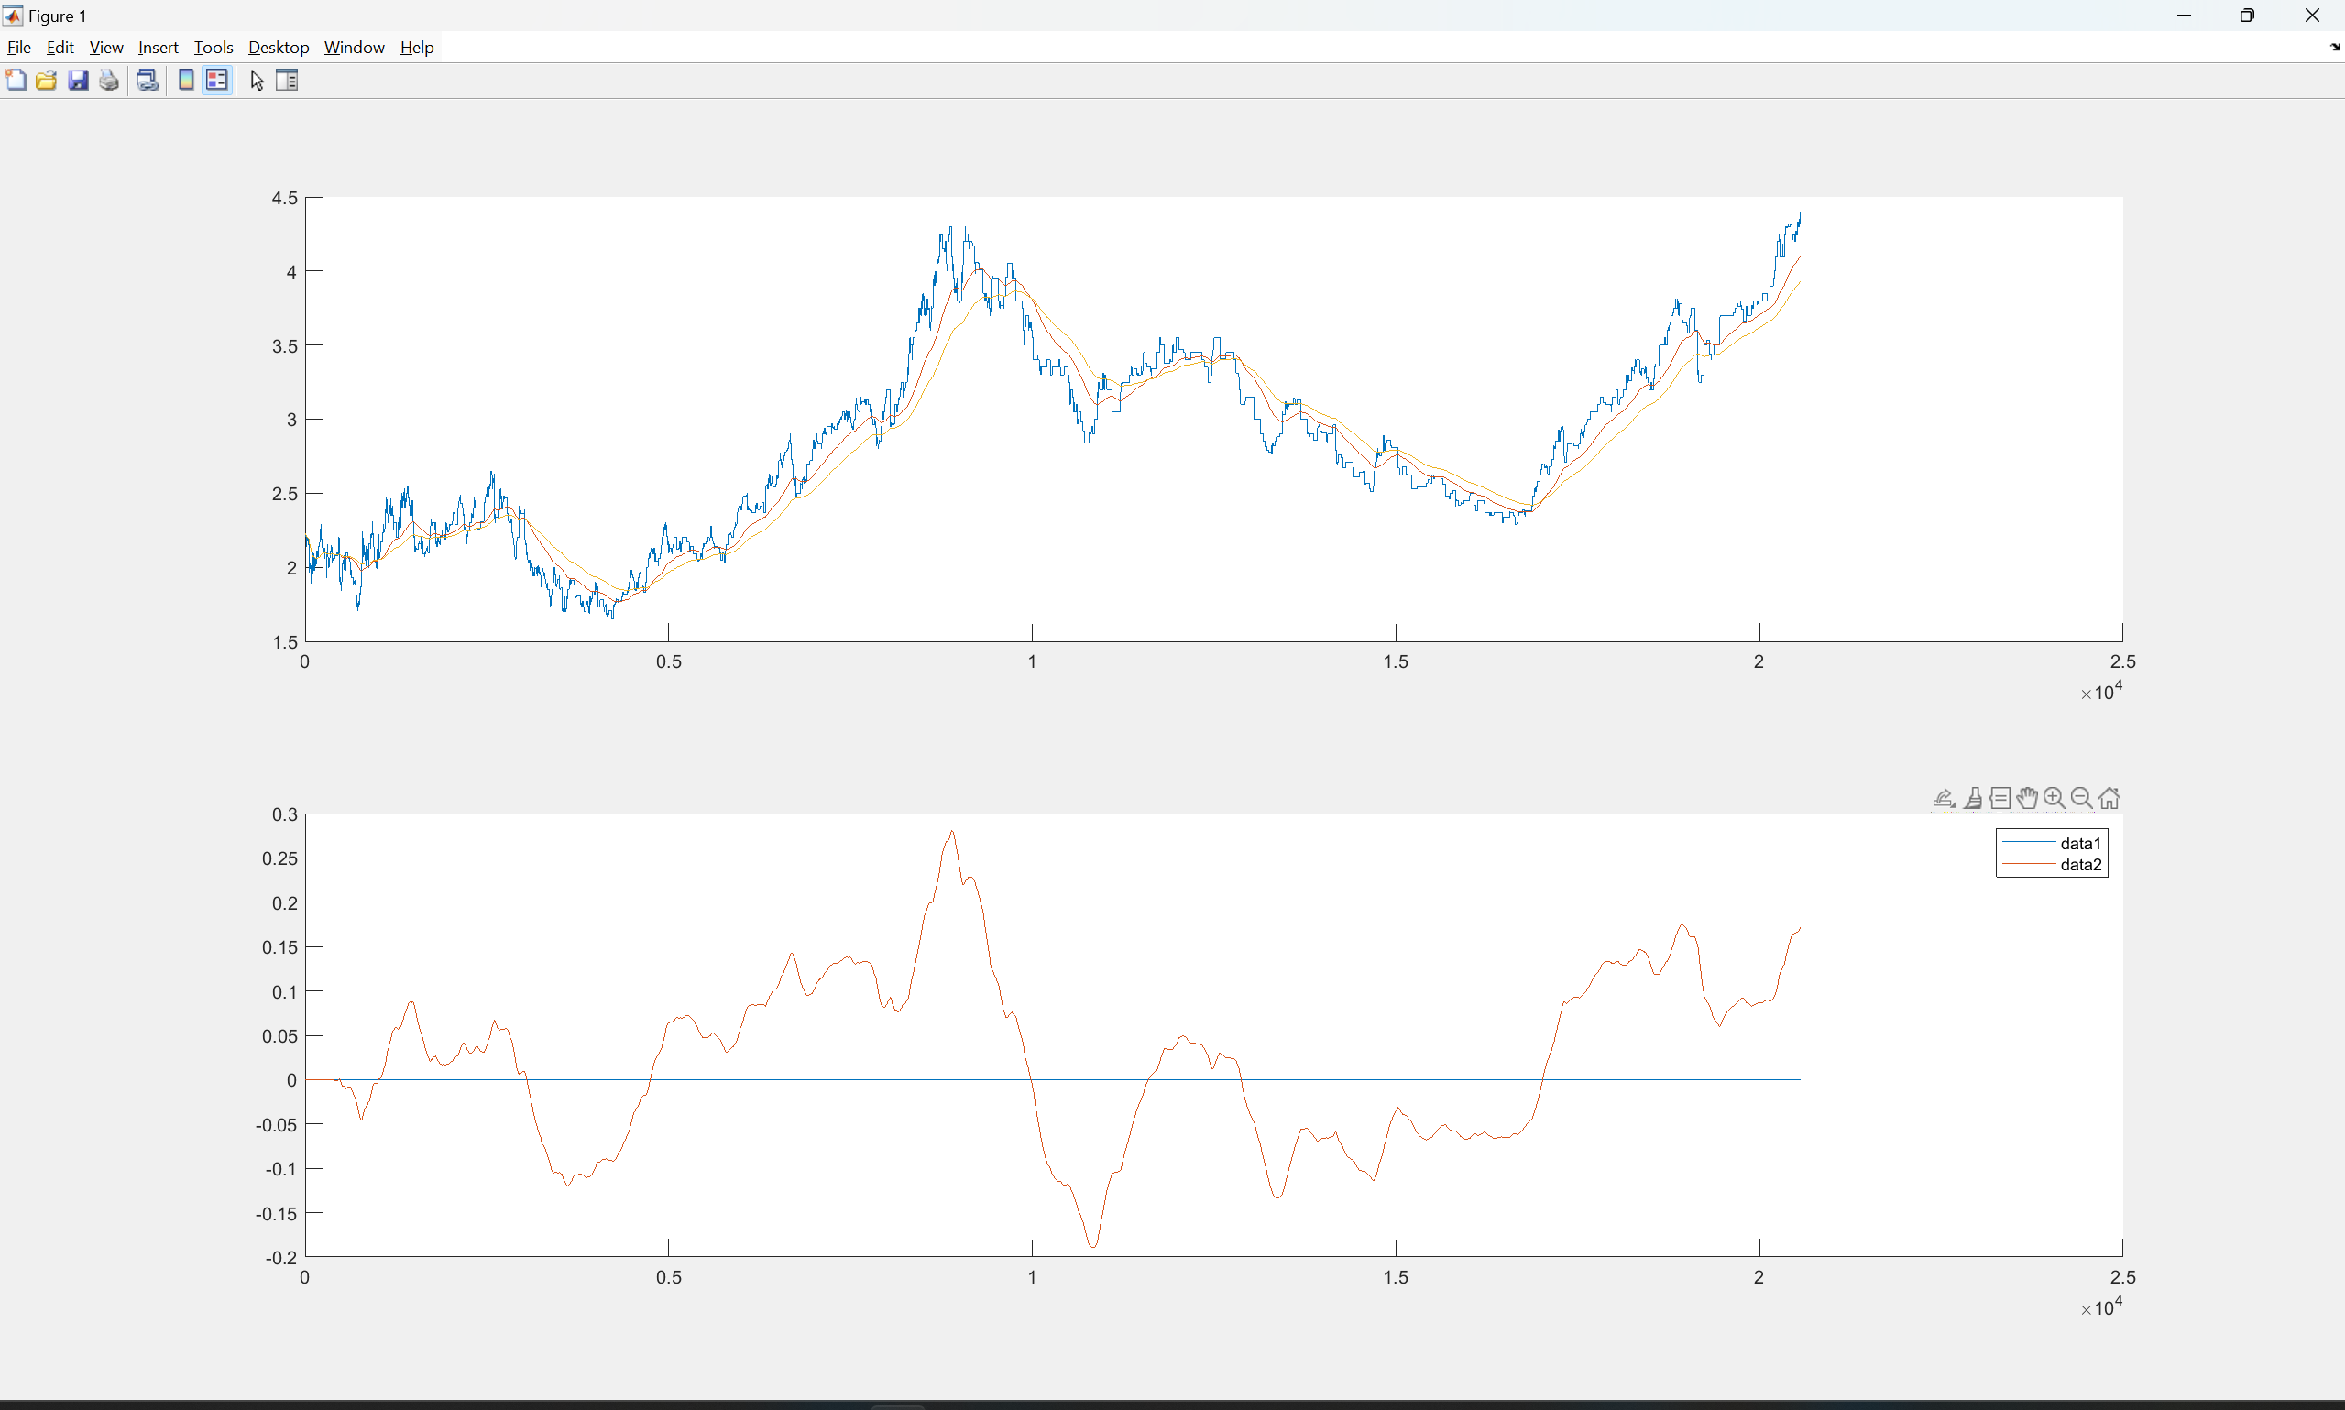

QQQ1211 C+P
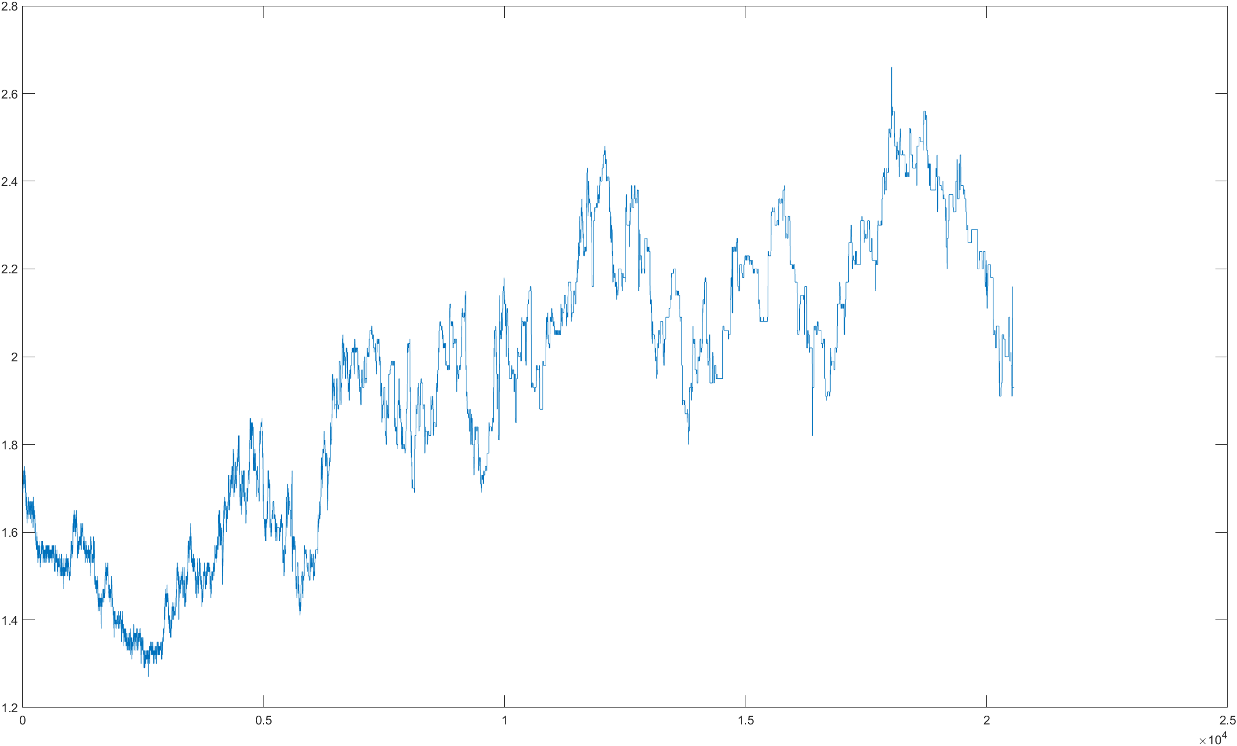
SPY1211 C+P
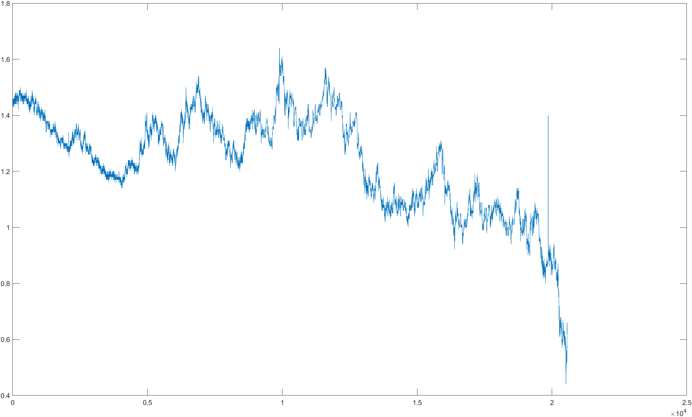
IWM1211 C+P
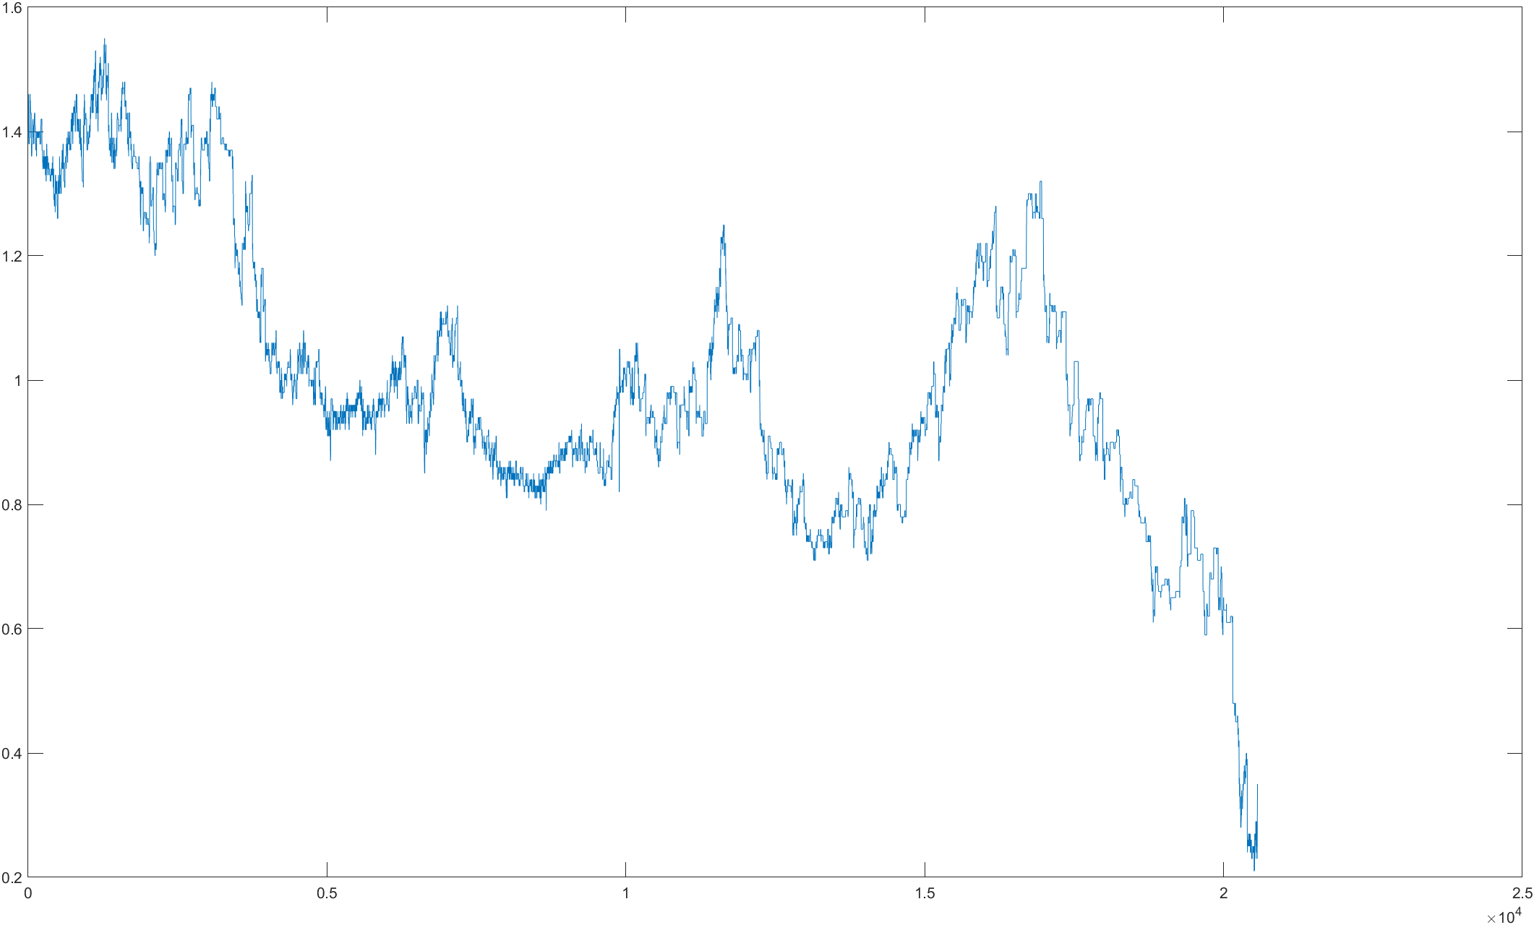
NVDA
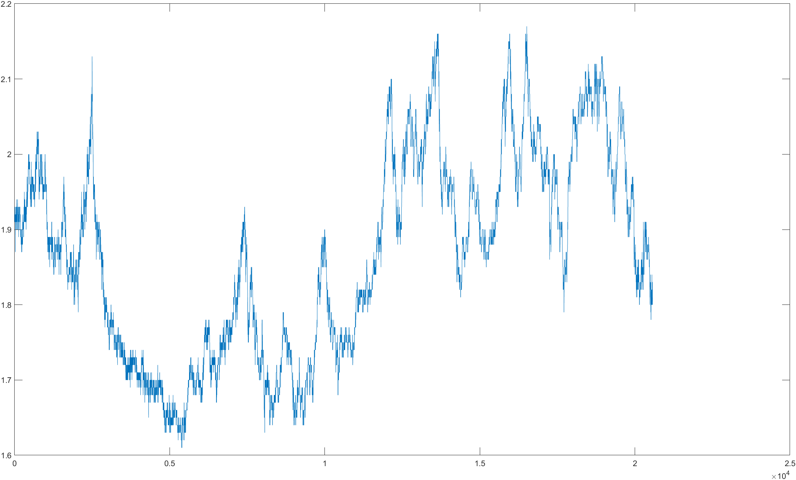
AMD
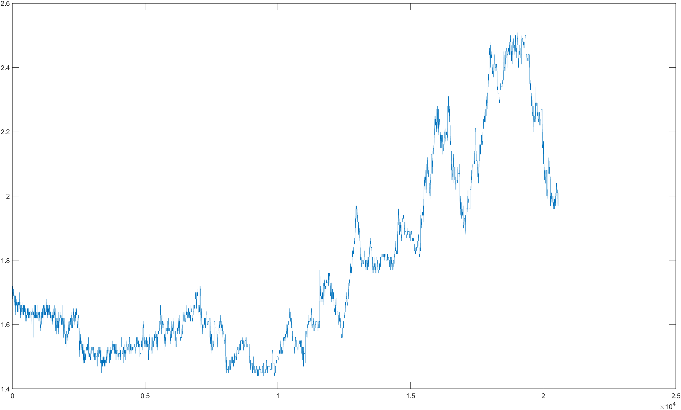

1209NVDA (stock, C+P, C, P)
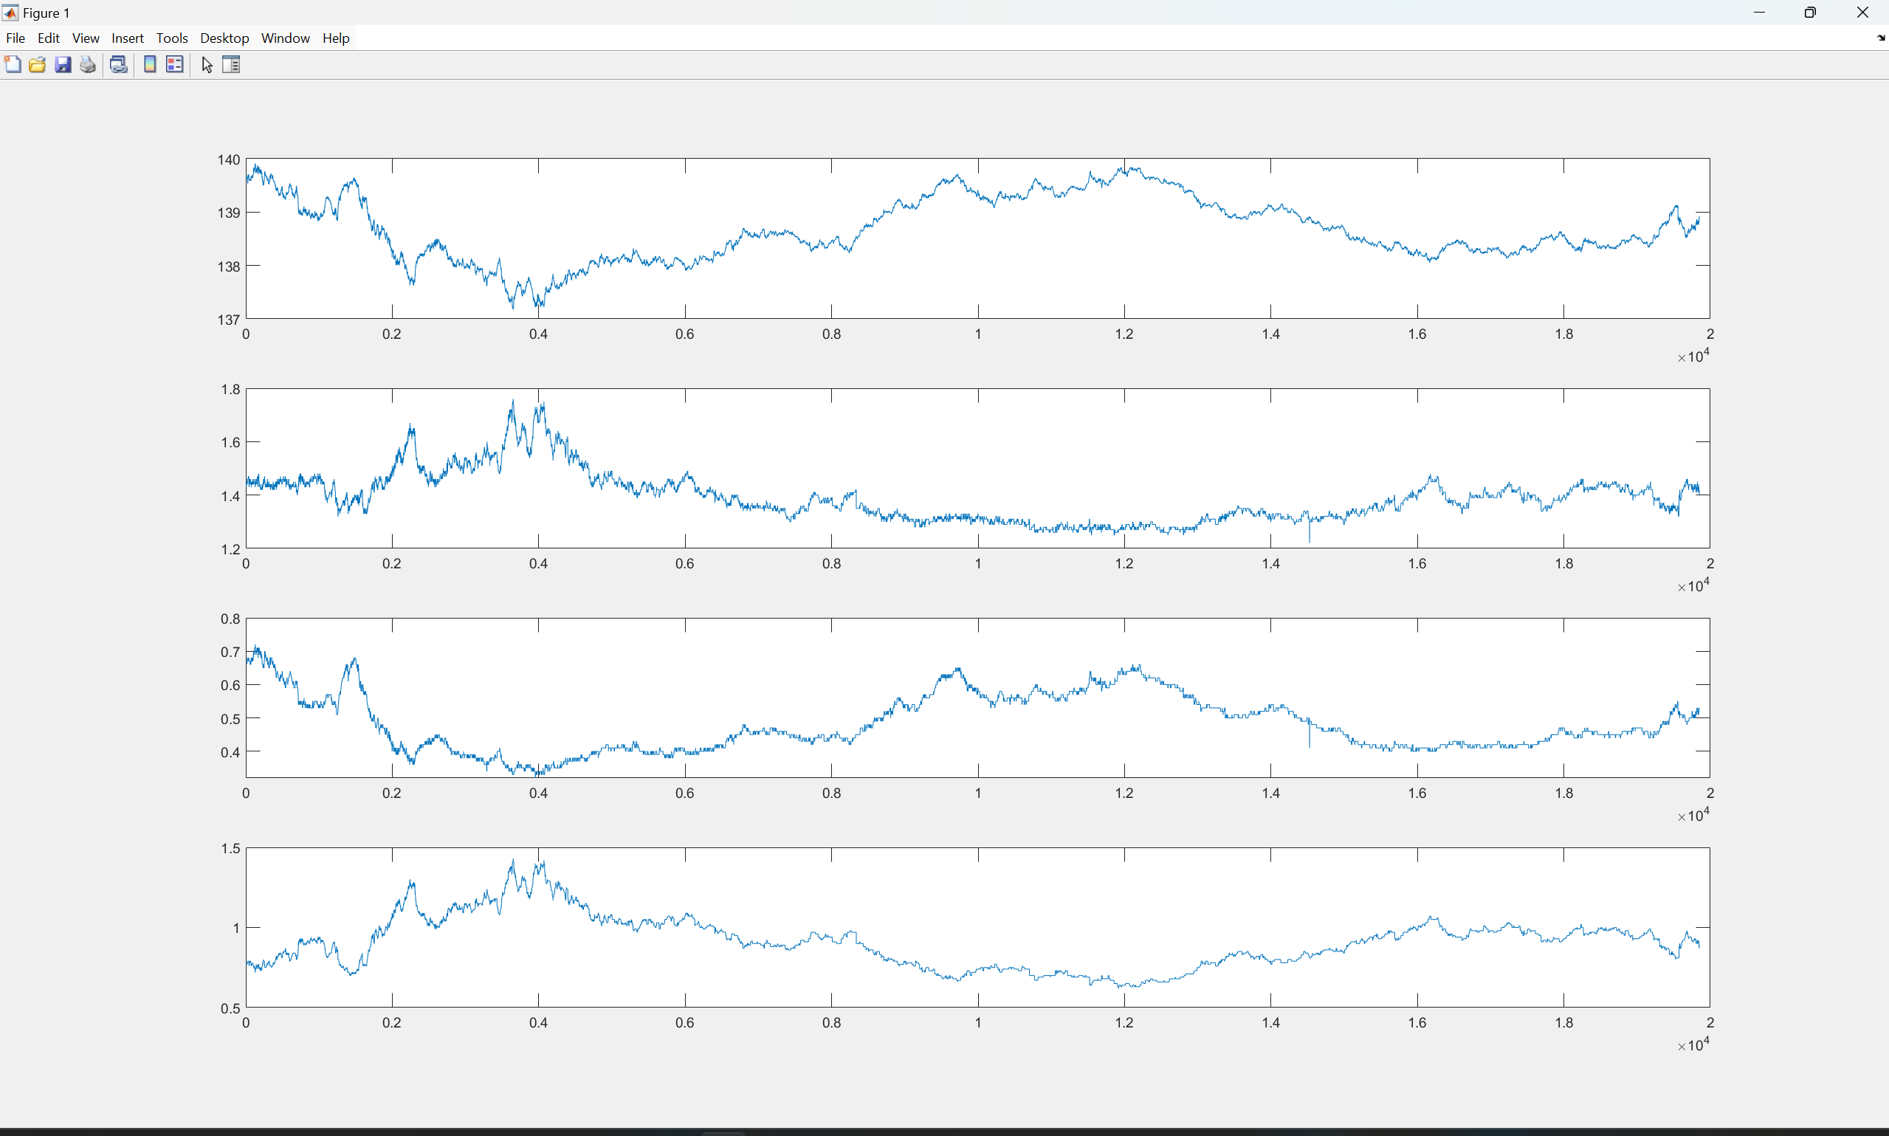
1209QQQ
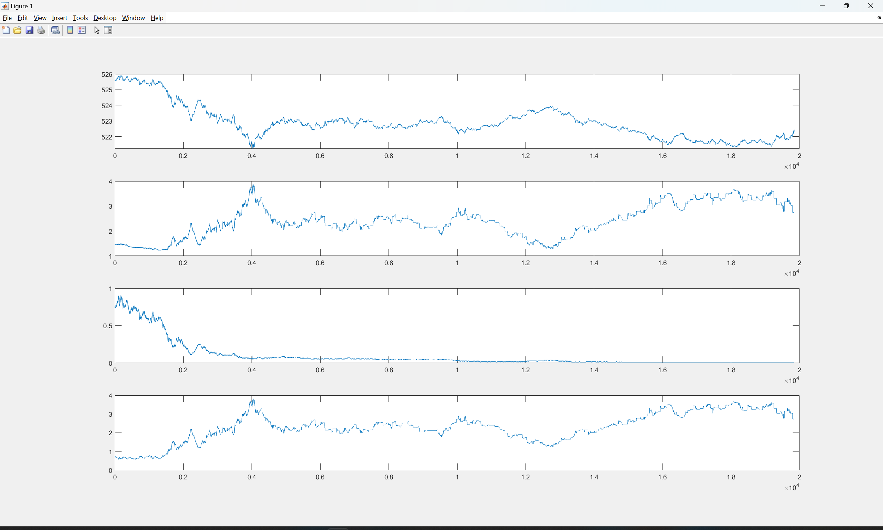
1209SPY
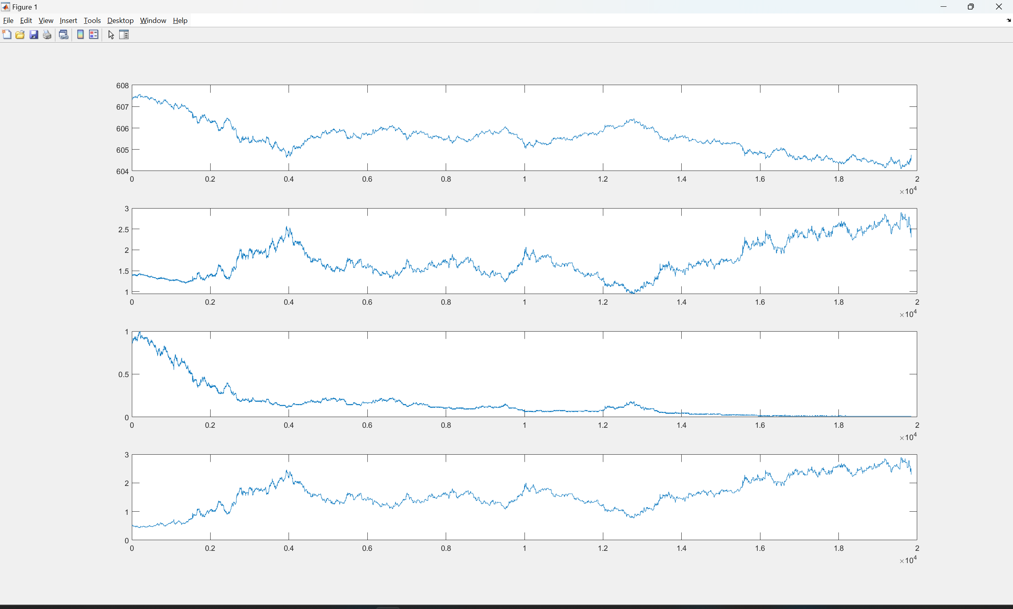
1209IWM
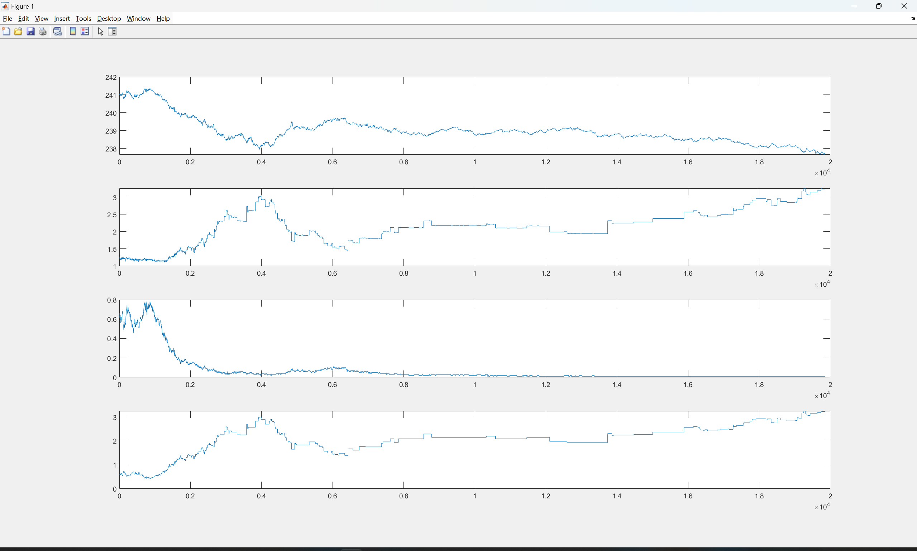
1210QQQ
1210SPY
1210IWM
1210AAPL (TOO STABLE)
1212AAPL
1216SOFI
SPY1217
MSTR1217
1219AAPPL
1219AMD
1219AMZN ATM
1219AMZN OTM
1219 AVGO
1219GOOGL
1219IWM
1219NVDA OTM
1219 NVDA ITM
PLTR ATM
PLTR OTM
1219QQQ OTM
1219QQQ ATM
1219 TSLA OTM
1220 AAPL V2 SELECTION 2.36->6.34
1220 AAPL V4 SELECTION 1.3->6.3
1220 AMD V2 1.3->1.9
1220 AMD V4 1.9->
1220 AVGO V2 1.8->5.3 (SAME FOR V4)

1220 IWM V2 1.5-3.6
1220 IWM V4 1.1-2.7
1220 MSTR V2
V4
1220 MU V2
1220 MU V4
1223 AMD
AVGO
IWM
MSTR
MU
NVDA
PLTR
QQQ
SOXL
SPY
TSLA

